# Microsoft ADC Cybersecurity Skilling Program

# WEEK 6 ASSIGNMENT 11

**STUDENT NAME:** DEBORAH BINYANYA

**STUDENT ID:** **ADC-CSS02-25051**

## Introduction

This week, I will be completing AZ-500 Lab 02: Network Security Groups and Application Security Groups. The lab focuses on implementing and managing network security using Azure's built-in tools. In this exercise, I will be working with two groups of servers—Web Servers and Management Servers—each assigned to its own Application Security Group (ASG). My task will be to configure Network Security Groups (NSGs) to control traffic flow. I will ensure that RDP access is only allowed to the Management Servers, while the Web Servers are restricted from RDP but remain accessible from the internet through their IIS web page. This lab will help me understand how ASGs and NSGs can be effectively used to secure network resources in Azure.

## Tasks Completed

# AZ500 LAB 02: NETWORK SECURITY GROUPS AND APPLICATION SECURITY GROUPS

Hello Deborah, on [SEA-Dev](https://labclient.labondemand.com/Instructions/40d189c6-76c8-4553-84b6-9ce29fa164de) click [Ctrl+Alt+Delete](https://labclient.labondemand.com/Instructions/40d189c6-76c8-4553-84b6-9ce29fa164de) to activate the Ctrl + Alt + Delete sequence and bring up the logon page.

Sign in as Admin with the password Pa55w.rd.

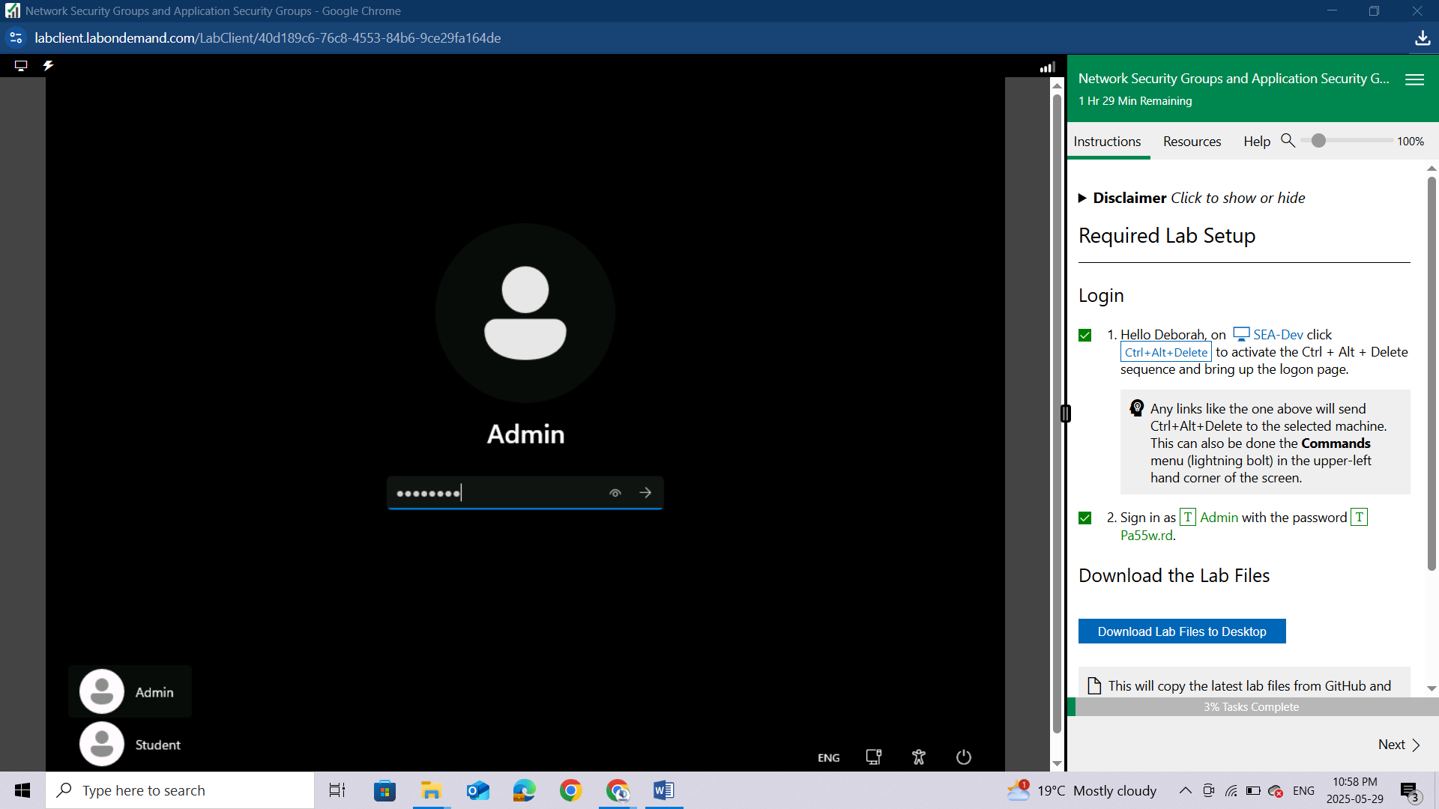

**Download the Lab Files**

Once you have received the 'Success!' message, click Next to proceed to the lab.

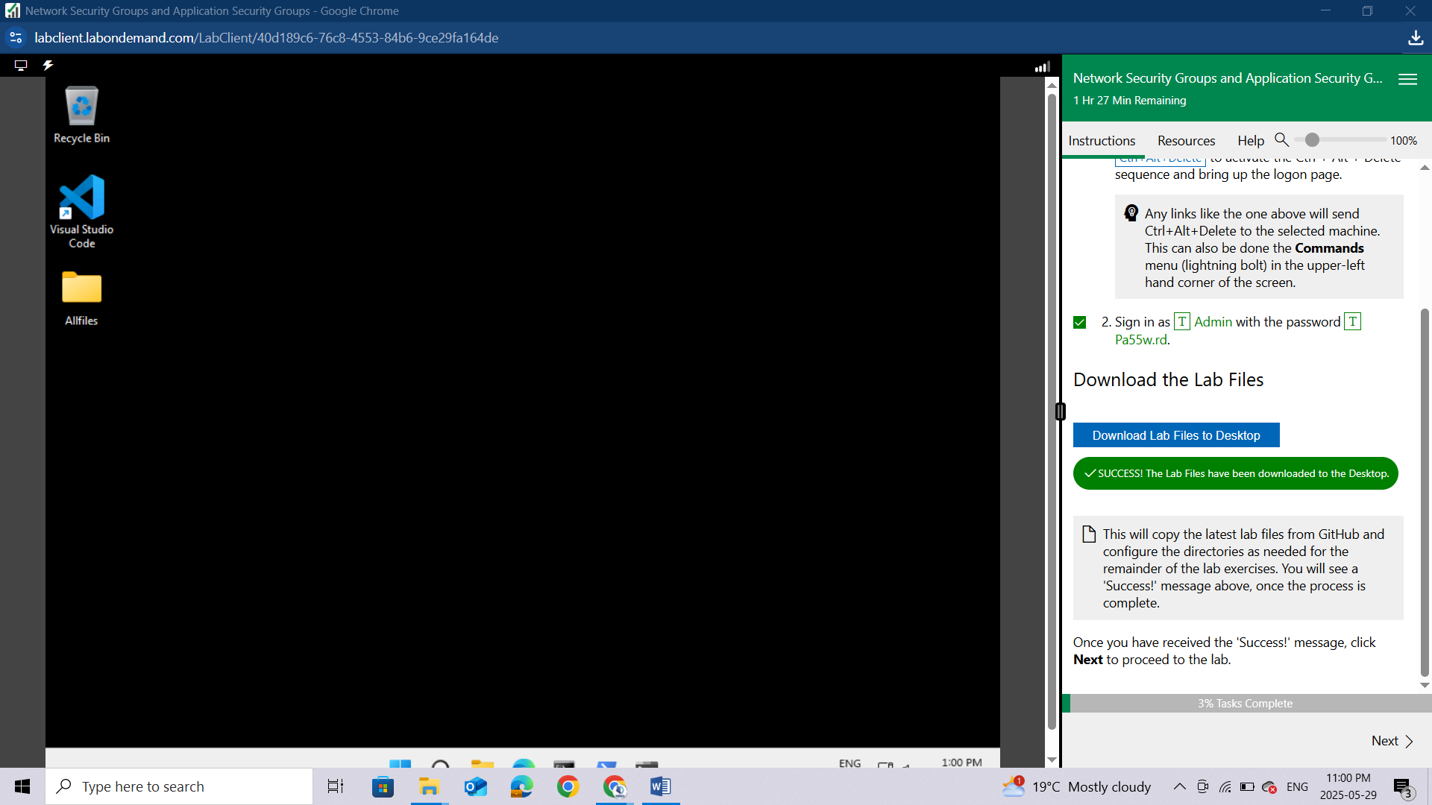

# Lab 02: Network Security Groups and Application Security Groups

### Lab scenario

You have been asked to implement your organization's virtual networking infrastructure and test to ensure it is working correctly. In particular:

* The organization has two groups of servers: Web Servers and Management Servers.
* Each group of servers should be in its own Application Security Group.
* You should be able to RDP into the Management Servers, but not the Web Servers.
* The Web Servers should display the IIS web page when accessed from the internet.
* Network security group rules should be used to control network access.

***For all the resources in this lab, we are using the*** *East US* ***region. Verify with your instructor this is the region to use for class.***

### Lab objectives

In this lab, you will complete the following exercises:

* Exercise 1: Create the virtual networking infrastructure
* Exercise 2: Deploy virtual machines and test the network filters

**Network and Application Security Groups diagram**

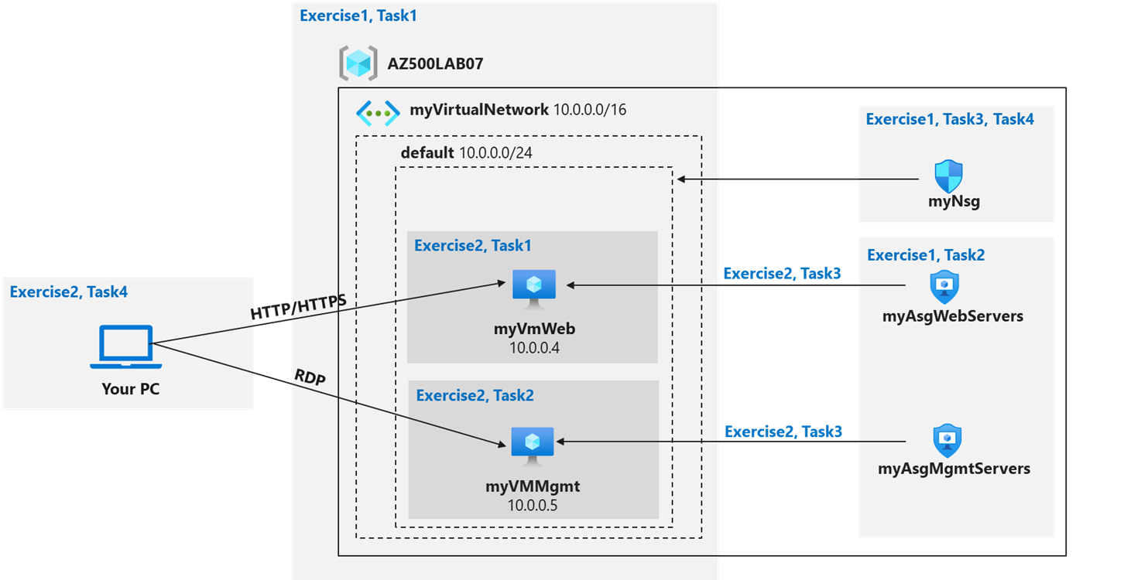

### Instructions

## Exercise 1: Create the virtual networking infrastructure

Estimated timing: 20 minutes

In this exercise, you will complete the following tasks:

* Task 1: Create a virtual network with one subnet.
* Task 2: Create two application security groups.
* Task 3: Create a network security group and associate it with the virtual network subnet.
* Task 4: Create inbound NSG security rules to all traffic to web servers and RDP to the management servers.

#### **Task 1: Create a virtual network**

In this task, you will create a virtual network to use with the network and application security groups.

Sign-in to the Azure portal **https://portal.azure.com/**.

Sign in to the Azure portal using an account that has the Owner or Contributor role in the Azure subscription you are using for this lab. In this **Cloudslice** lab, this account is LabUser-51781079@LODSPRODMCA.onmicrosoft.com with password Bd0Be1#!Dh3n

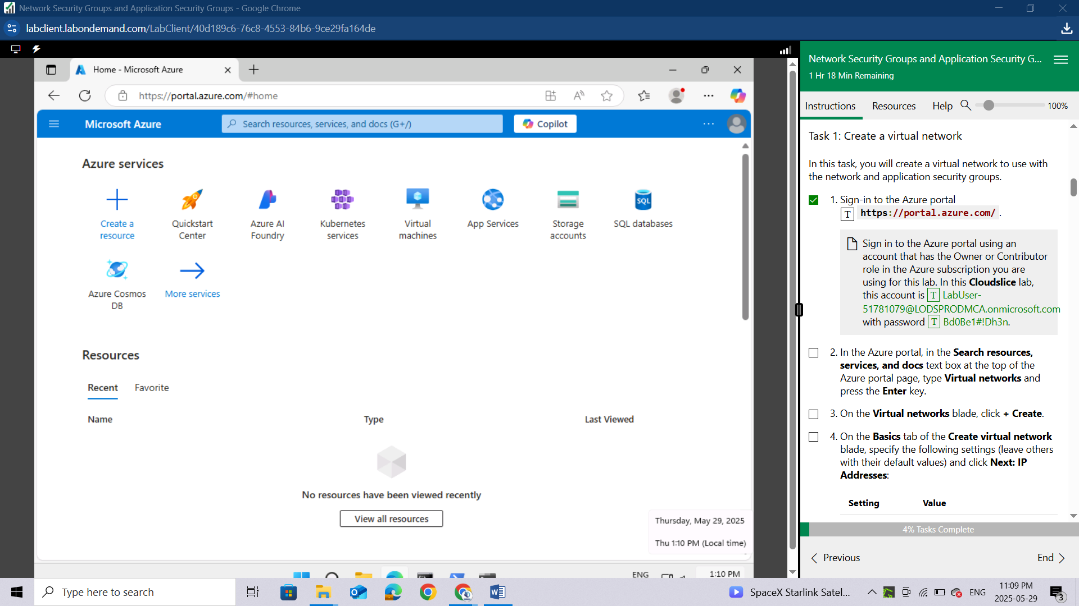

In the Azure portal, in the **Search resources, services, and docs** text box at the top of the Azure portal page, type **Virtual networks** and press the **Enter** key.

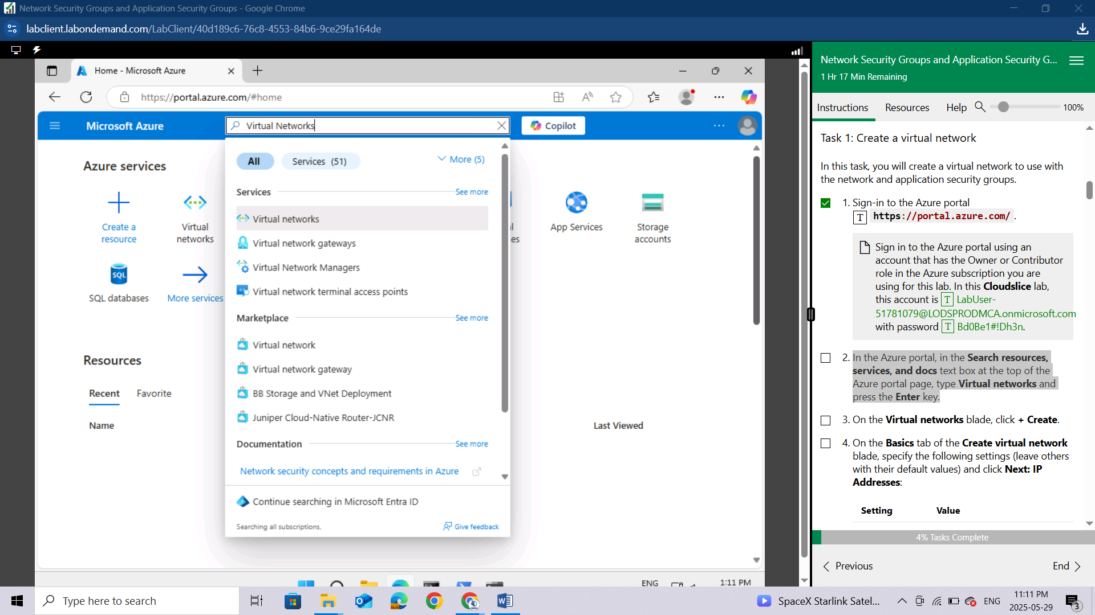

On the **Virtual networks** blade, click **+ Create**.

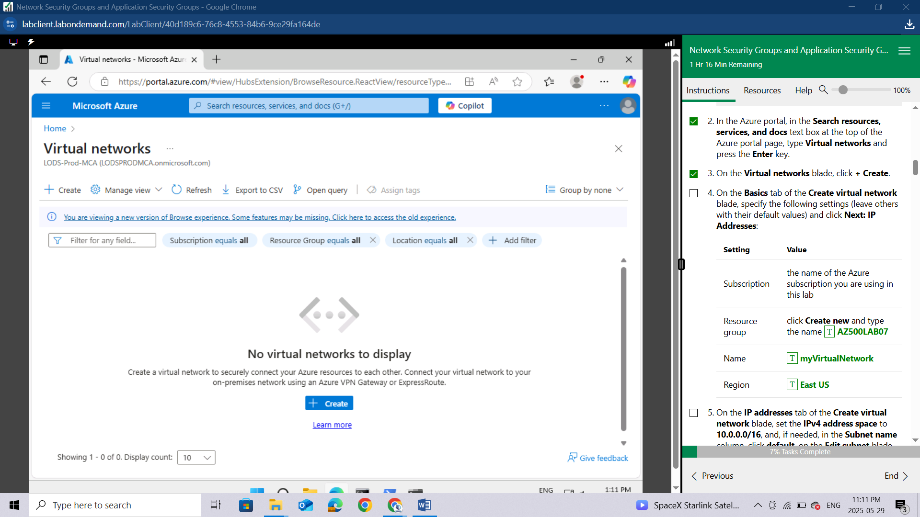

On the **Basics** tab of the **Create virtual network** blade, specify the following settings (leave others with their default values) and click **Next: IP Addresses**:

| **Setting** | **Value** |
| --- | --- |
| Subscription | the name of the Azure subscription you are using in this lab |
| Resource group | click **Create new** and type the name **AZ500LAB07** |
| Name | **myVirtualNetwork** |
| Region | **East US** |

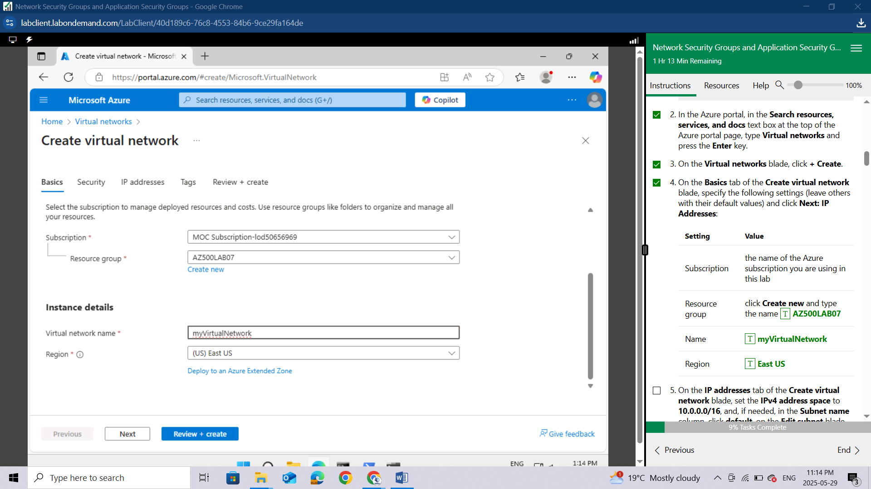

On the **IP addresses** tab of the **Create virtual network** blade, set the **IPv4 address space** to **10.0.0.0/16**, and, if needed, in the **Subnet name** column, click **default**, on the **Edit subnet** blade, specify the following settings and click **Save**:

| **Setting** | **Value** |
| --- | --- |
| Subnet name | **default** |
| Subnet address range | **10.0.0.0/24** |

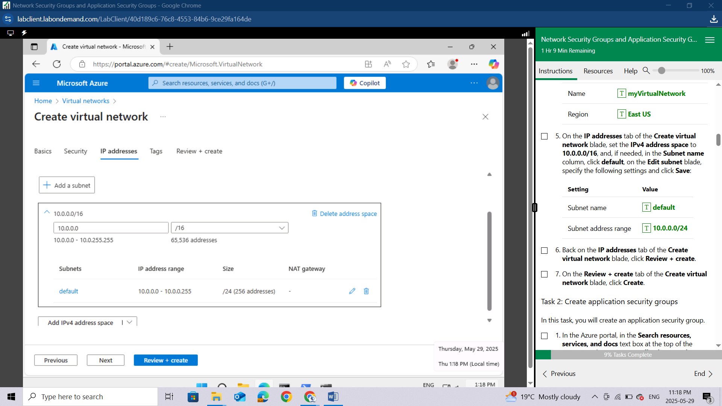

Back on the **IP addresses** tab of the **Create virtual network** blade, click **Review + create**.

On the **Review + create** tab of the **Create virtual network** blade, click **Create**.

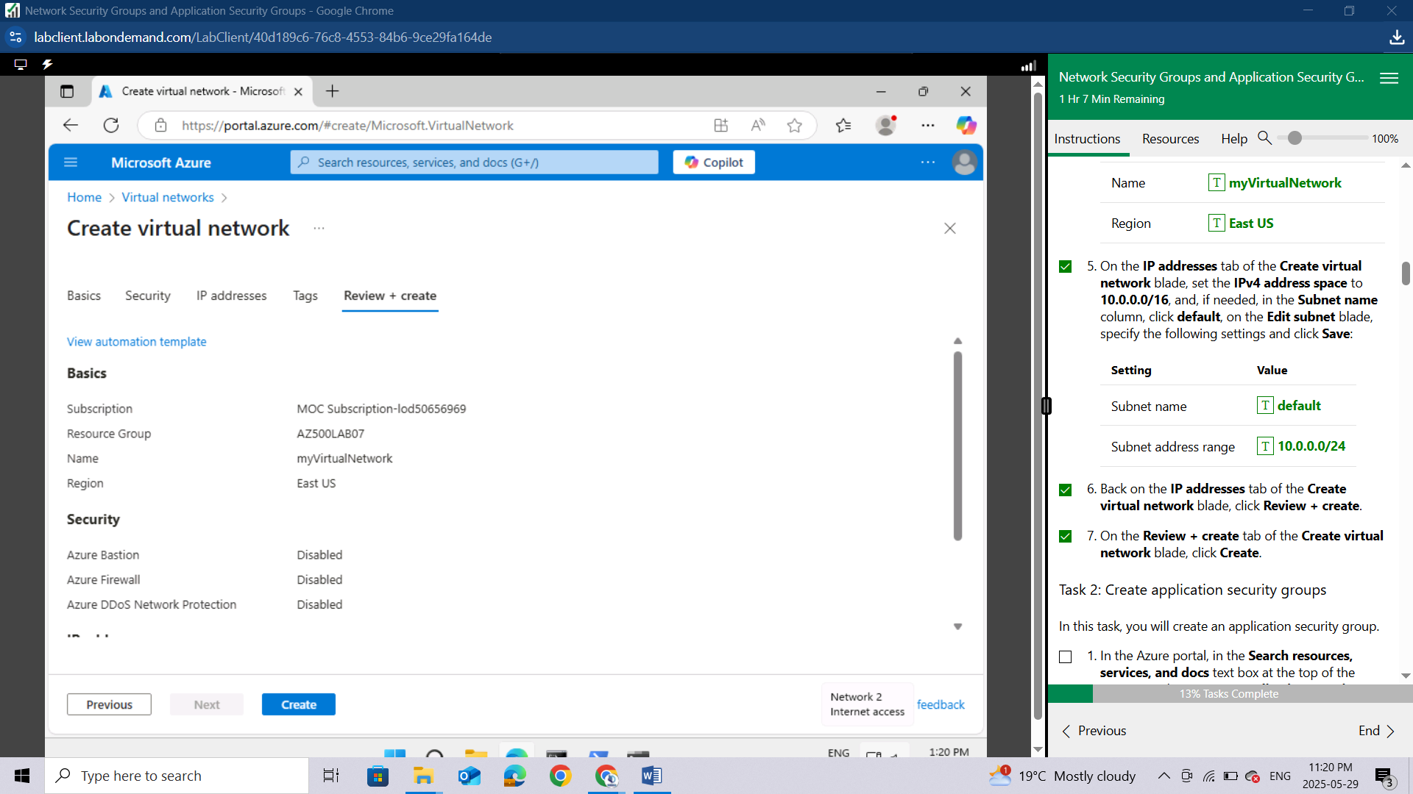

#### **Task 2: Create application security groups**

In this task, you will create an application security group.

In the Azure portal, in the **Search resources, services, and docs** text box at the top of the Azure portal page, type **Application security groups** and press the **Enter** key.

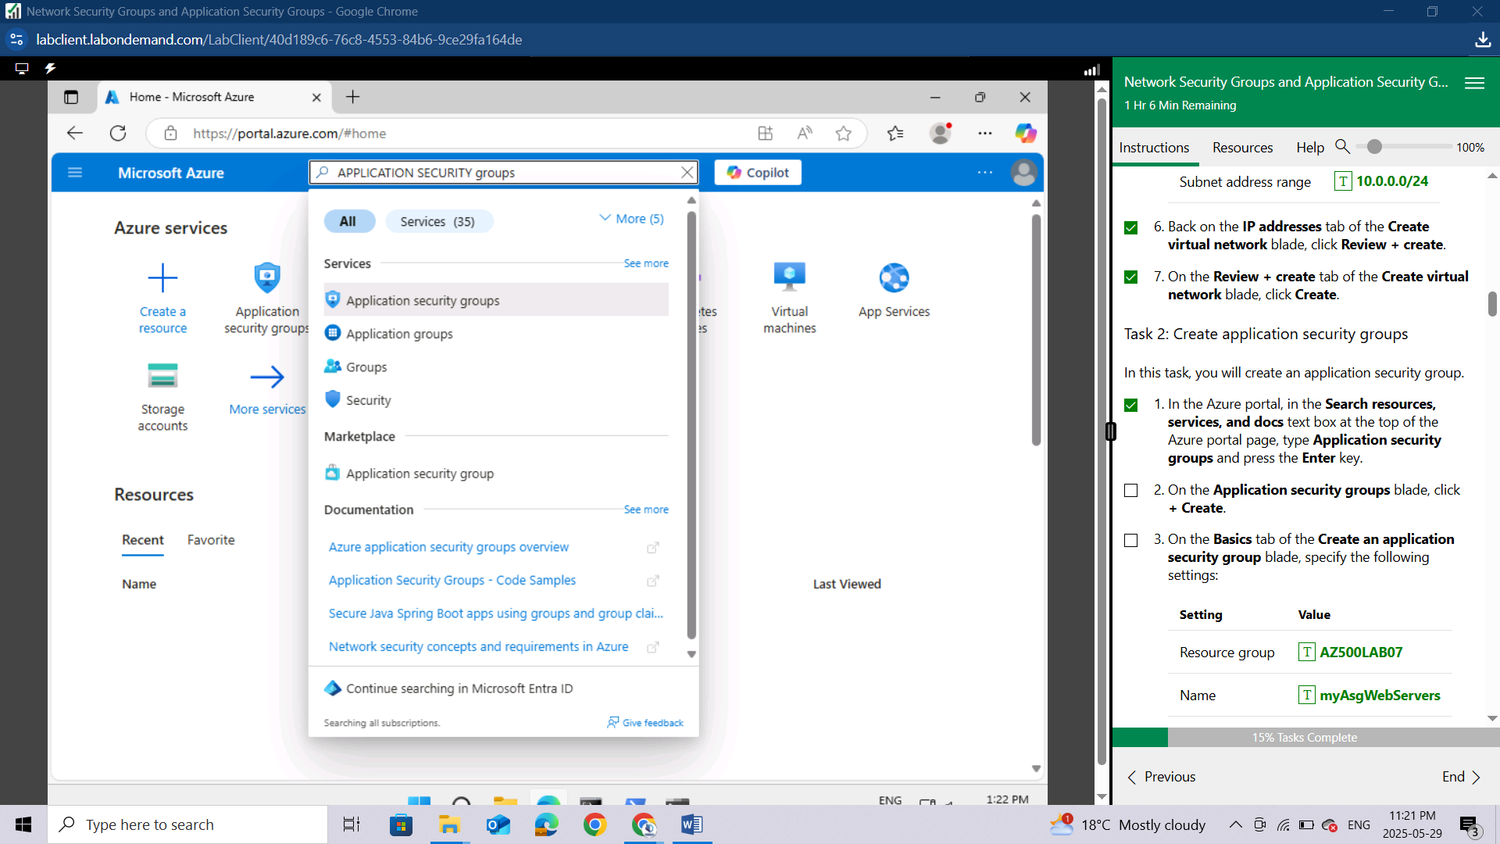

On the **Application security groups** blade, click **+ Create**.

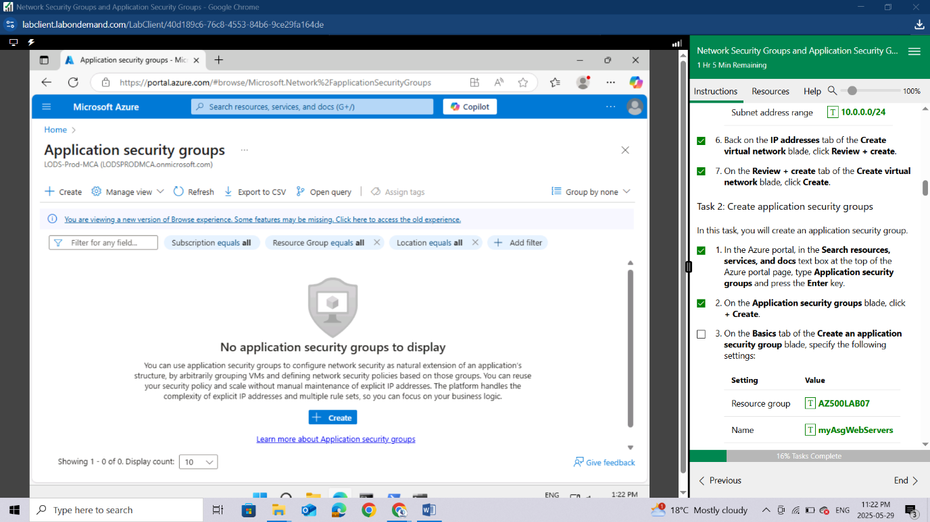

On the **Basics** tab of the **Create an application security group** blade, specify the following settings:

| **Setting** | **Value** |
| --- | --- |
| Resource group | **AZ500LAB07** |
| Name | **myAsgWebServers** |
| Region | **East US** |

This group will be for the web servers.

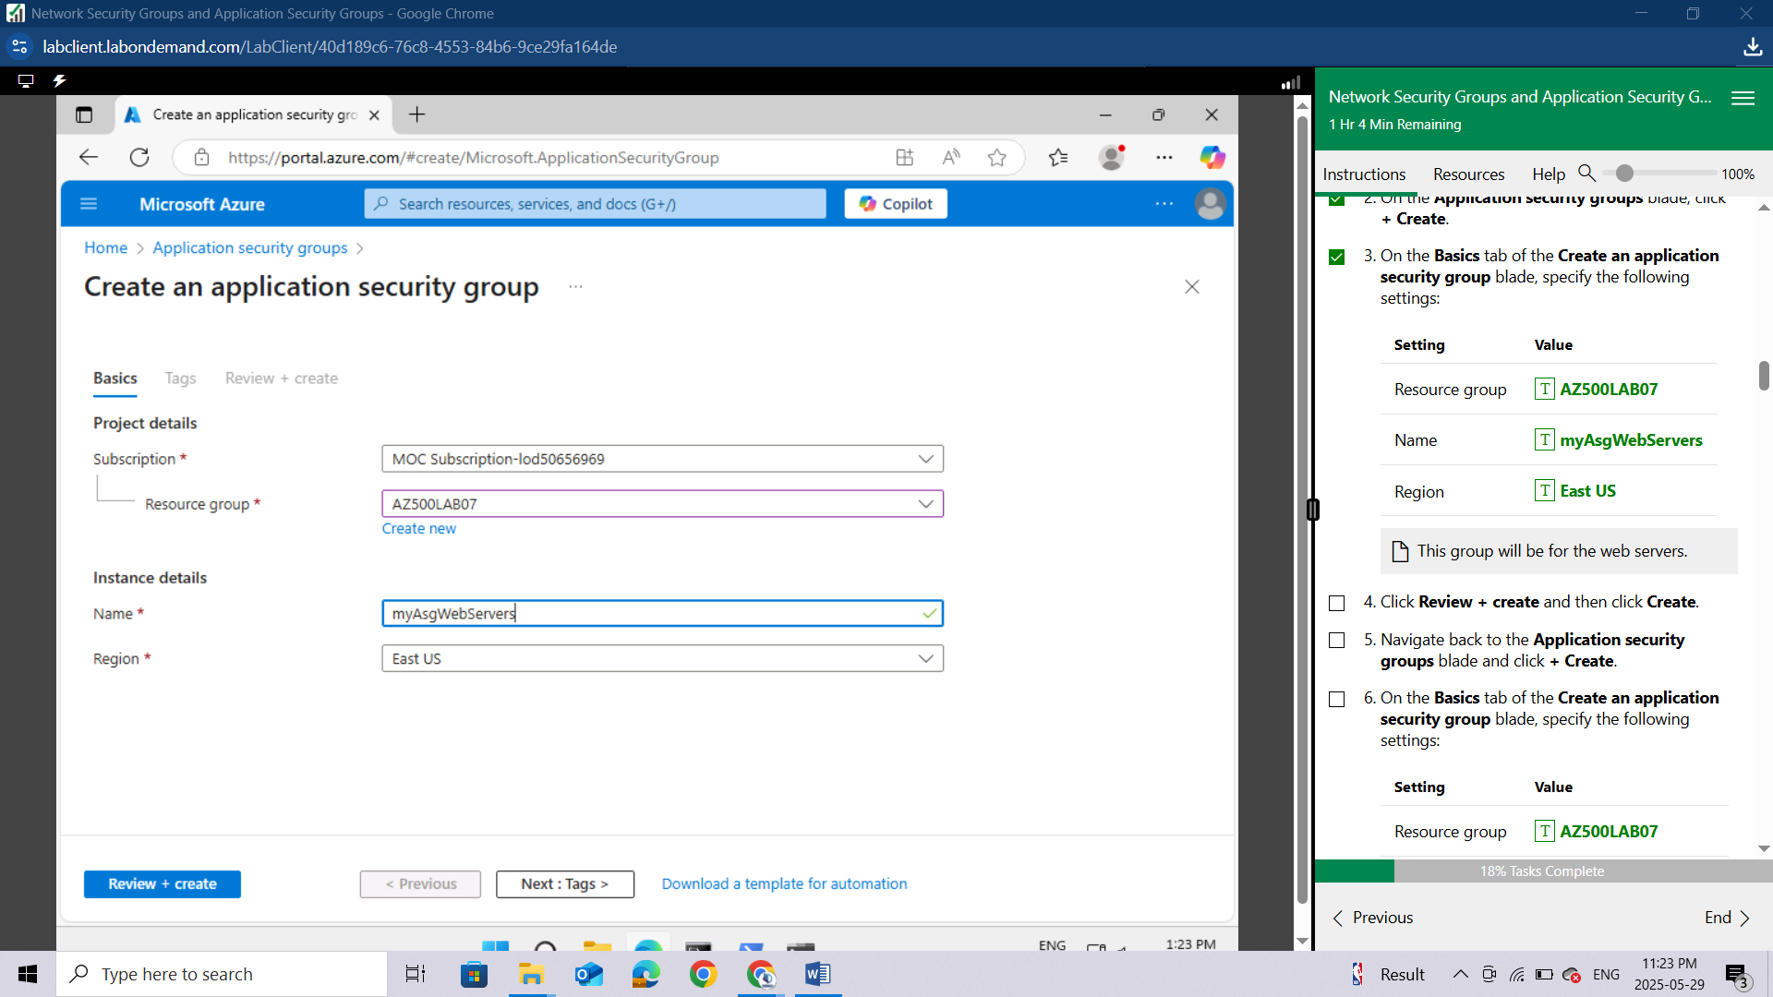

Click **Review + create** and then click **Create**.

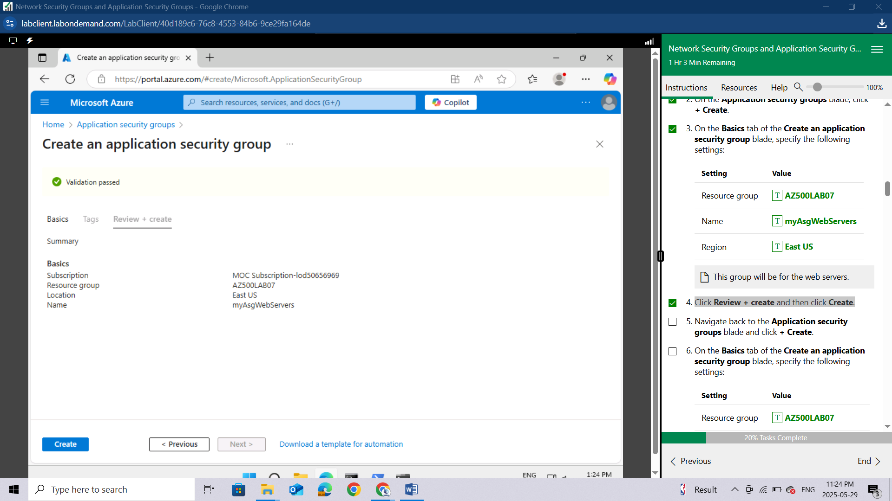

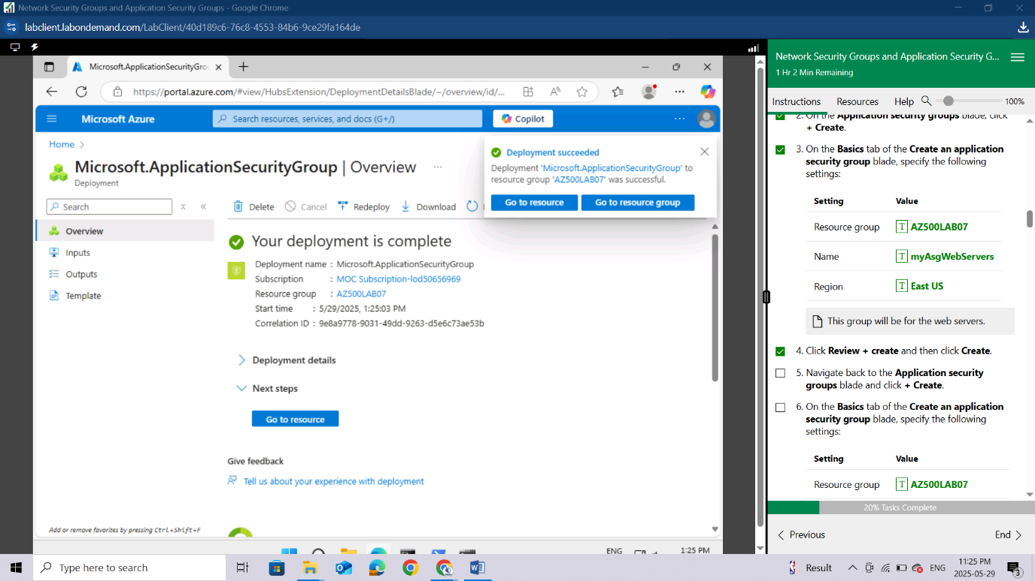

Navigate back to the **Application security groups** blade and click **+ Create**.

On the **Basics** tab of the **Create an application security group** blade, specify the following settings:

| **Setting** | **Value** |
| --- | --- |
| Resource group | **AZ500LAB07** |
| Name | **myAsgMgmtServers** |
| Region | **East US** |

This group will be for the management servers.

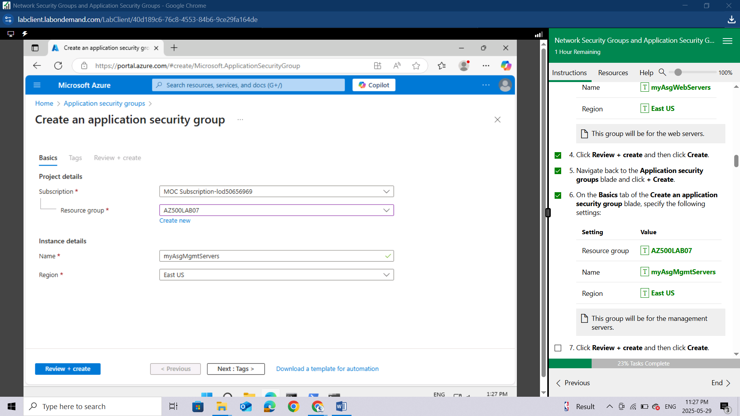

Click **Review + create** and then click **Create**.

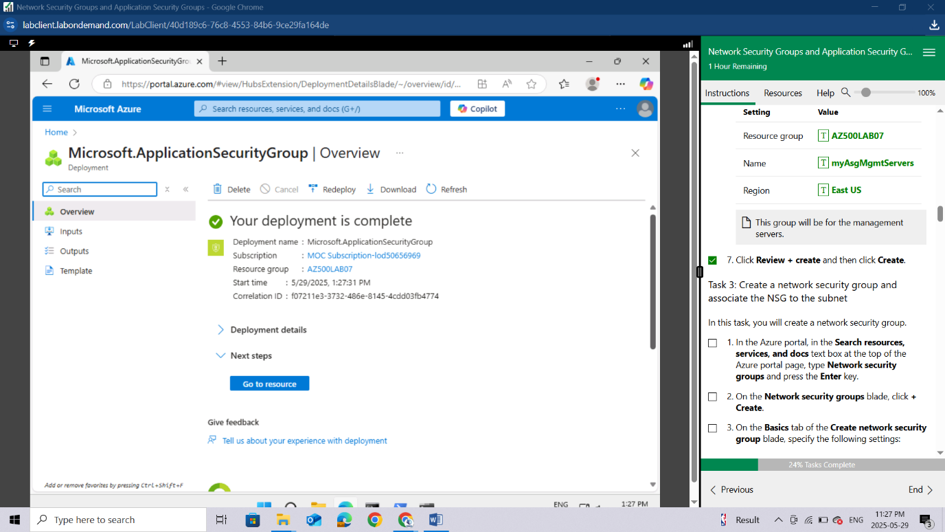

#### **Task 3: Create a network security group and associate the NSG to the subnet**

In this task, you will create a network security group.

In the Azure portal, in the **Search resources, services, and docs** text box at the top of the Azure portal page, type **Network security groups** and press the **Enter** key.

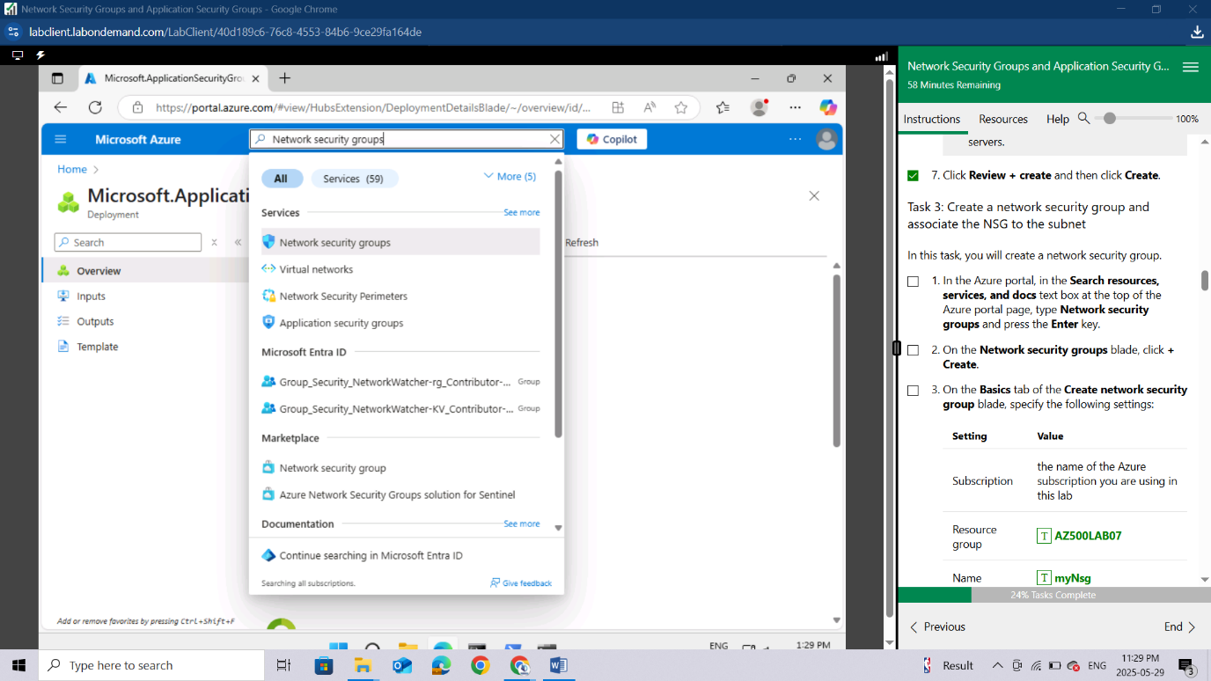

On the **Network security groups** blade, click **+ Create**.

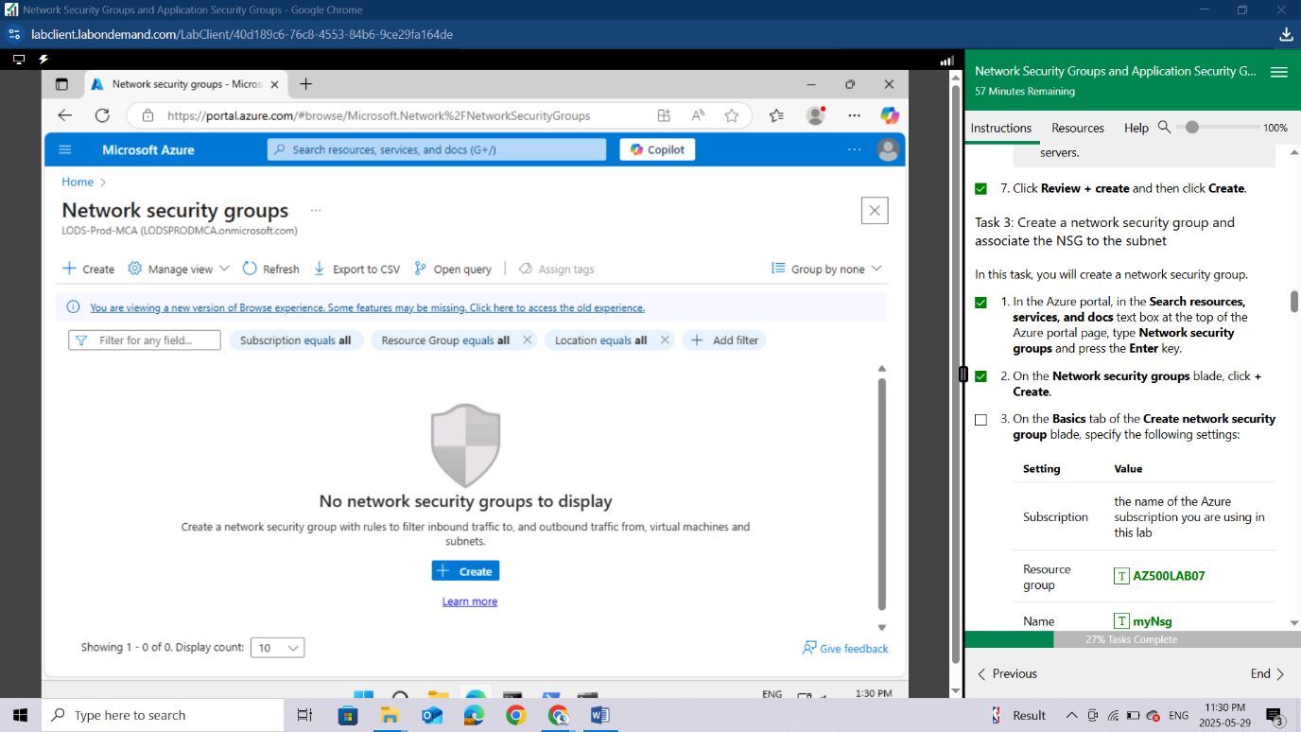

On the **Basics** tab of the **Create network security group** blade, specify the following settings:

| **Setting** | **Value** |
| --- | --- |
| Subscription | the name of the Azure subscription you are using in this lab |
| Resource group | **AZ500LAB07** |
| Name | **myNsg** |
| Region | **East US** |

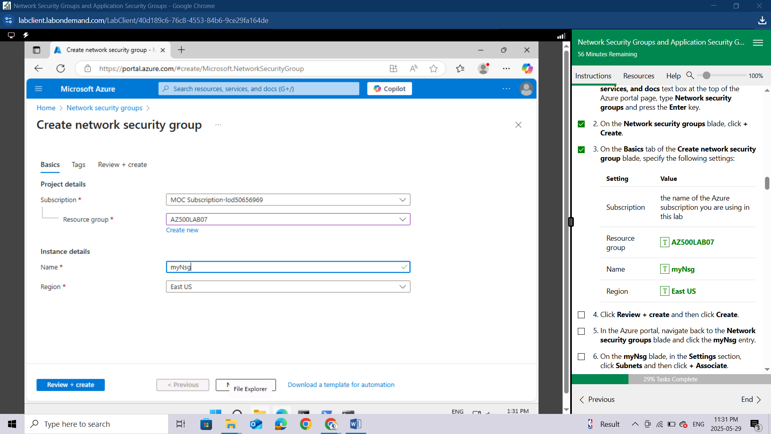

Click **Review + create** and then click **Create**.

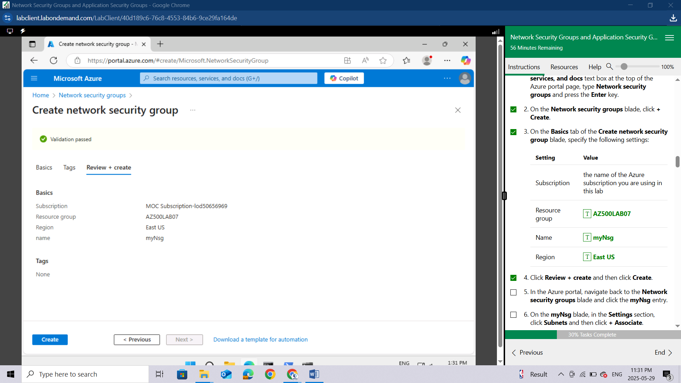

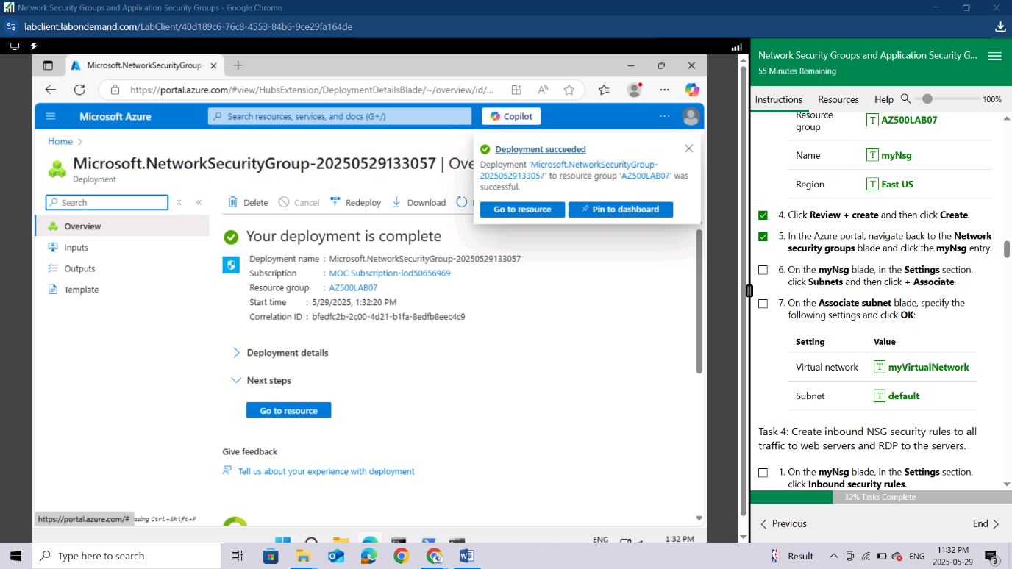

In the Azure portal, navigate back to the **Network security groups** blade and click the **myNsg** entry.

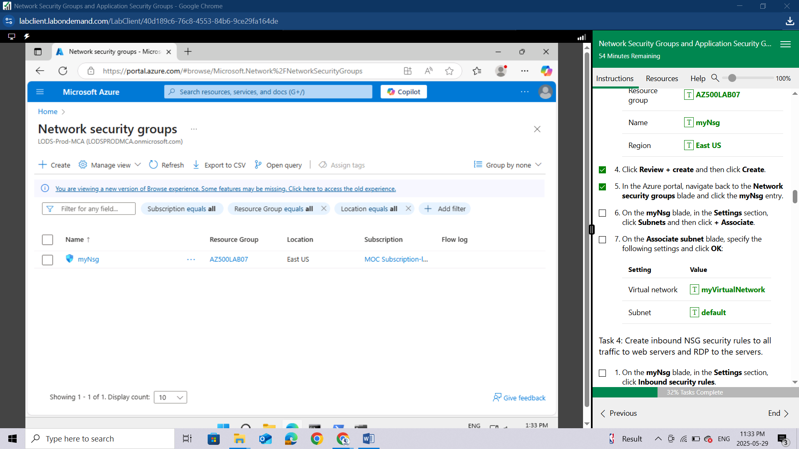

On the **myNsg** blade, in the **Settings** section, click **Subnets** and then click **+ Associate**.

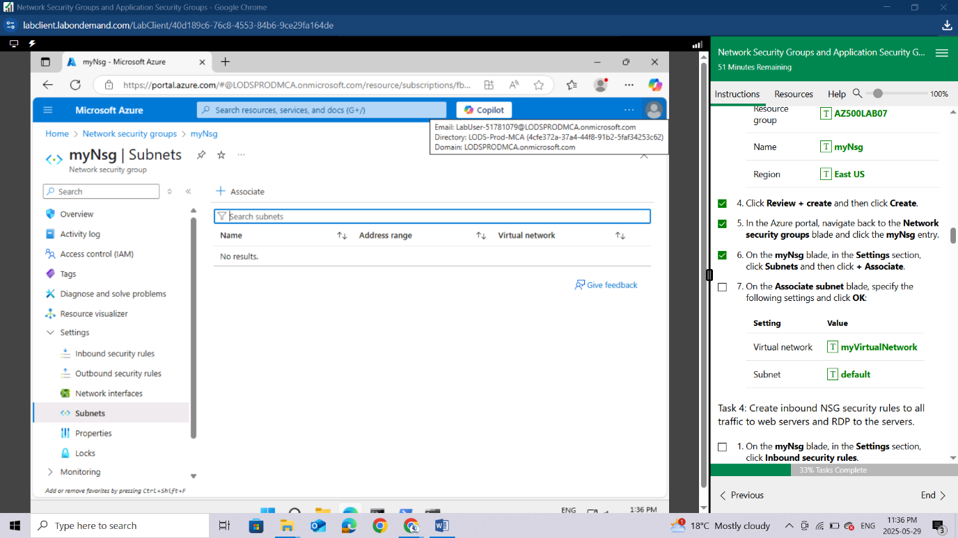

On the **Associate subnet** blade, specify the following settings and click **OK**:

| **Setting** | **Value** |
| --- | --- |
| Virtual network | **myVirtualNetwork** |
| Subnet | **default** |

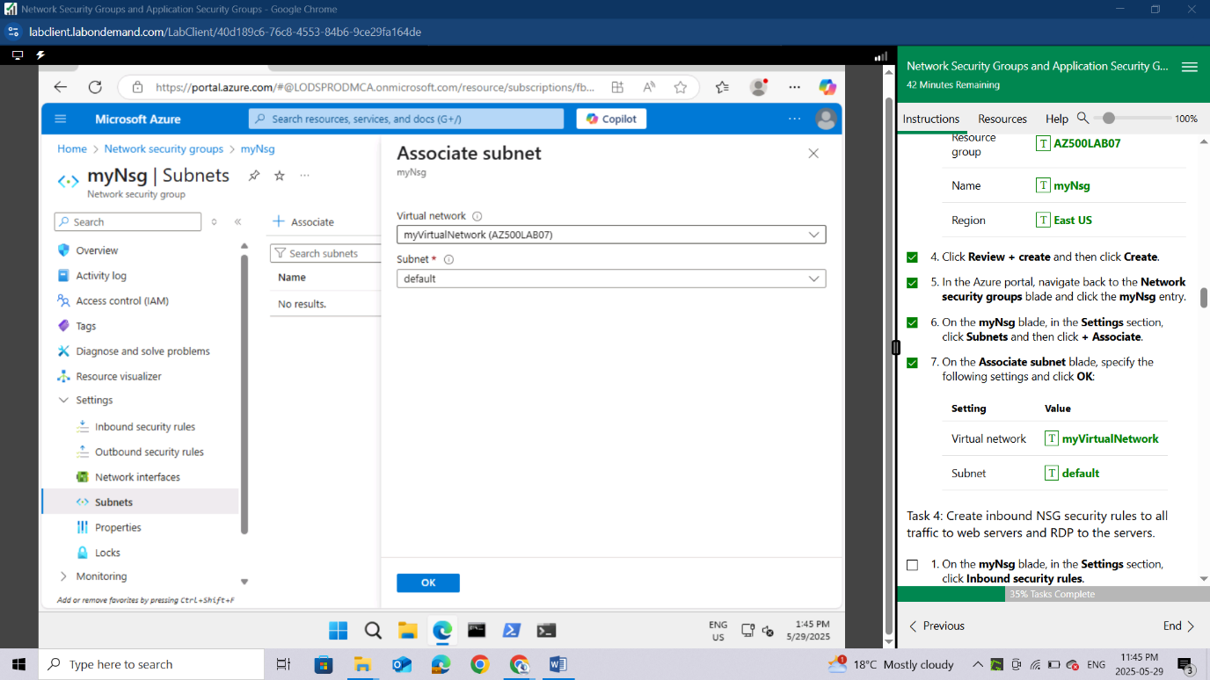

#### **Task 4: Create inbound NSG security rules to all traffic to web servers and RDP to the servers.**

On the **myNsg** blade, in the **Settings** section, click **Inbound security rules**.

Review the default inbound security rules and then click **+ Add**.

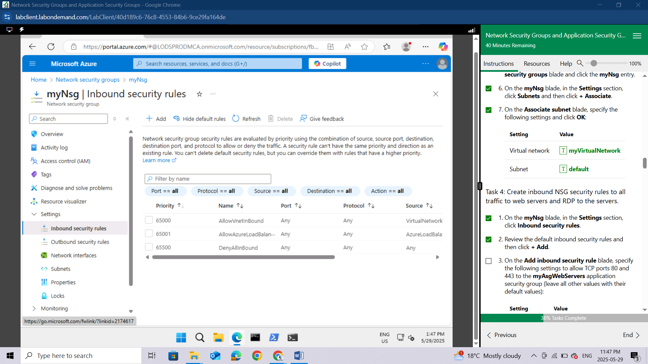

On the **Add inbound security rule** blade, specify the following settings to allow TCP ports 80 and 443 to the **myAsgWebServers** application security group (leave all other values with their default values):

| **Setting** | **Value** |
| --- | --- |
| Destination | in the drop-down list, select **Application security group** and then click **myAsgWebServers** |
| Destination port ranges | **80,443** |
| Protocol | **TCP** |
| Priority | **100** |
| Name | **Allow-Web-All** |

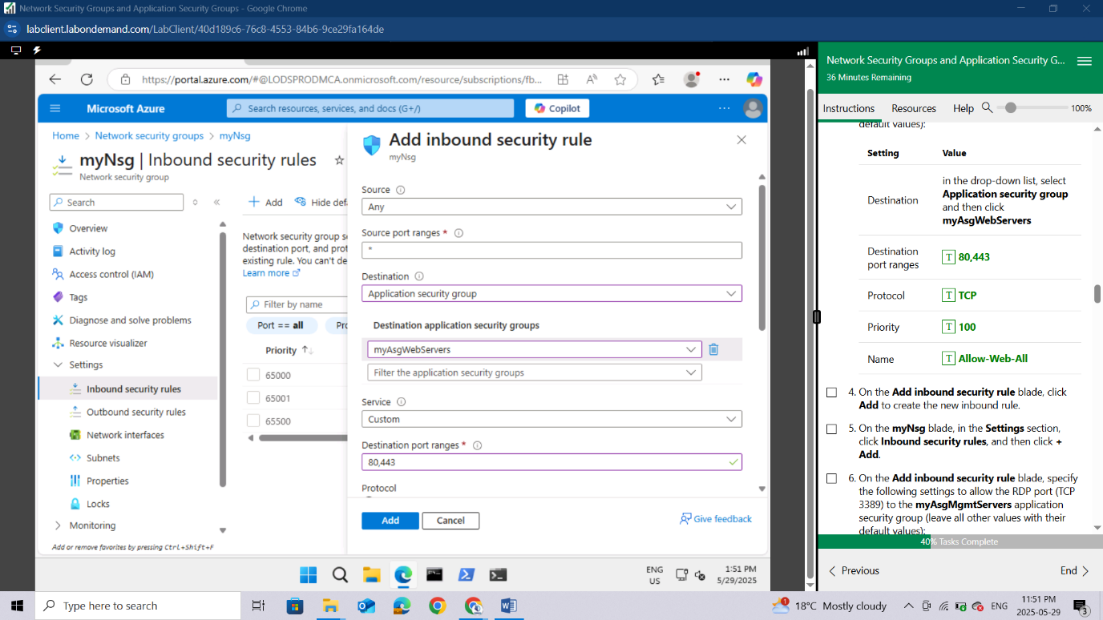

On the **Add inbound security rule** blade, click **Add** to create the new inbound rule.

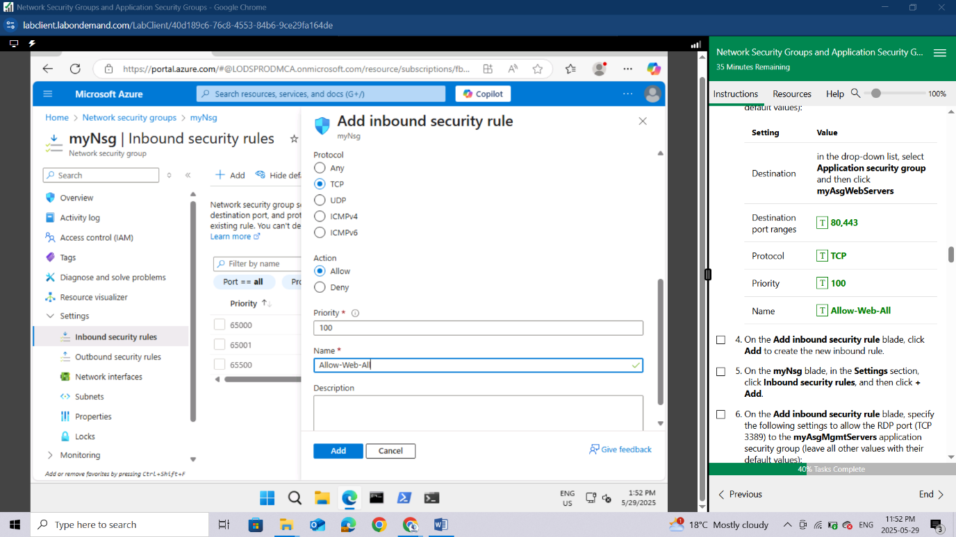

On the **myNsg** blade, in the **Settings** section, click **Inbound security rules**, and then click **+ Add**.

On the **Add inbound security rule** blade, specify the following settings to allow the RDP port (TCP 3389) to the **myAsgMgmtServers** application security group (leave all other values with their default values):

| **Setting** | **Value** |
| --- | --- |
| Destination | in the drop-down list, select **Application security group** and then click **myAsgMgmtServers** |
| Destination port ranges | **3389** |
| Protocol | **TCP** |
| Priority | **110** |
| Name | **Allow-RDP-All** |

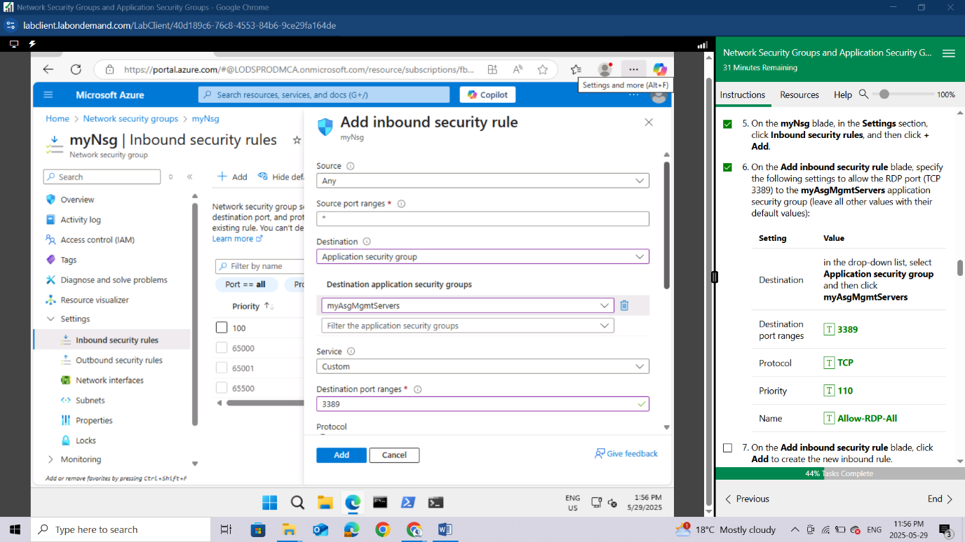

On the **Add inbound security rule** blade, click **Add** to create the new inbound rule.

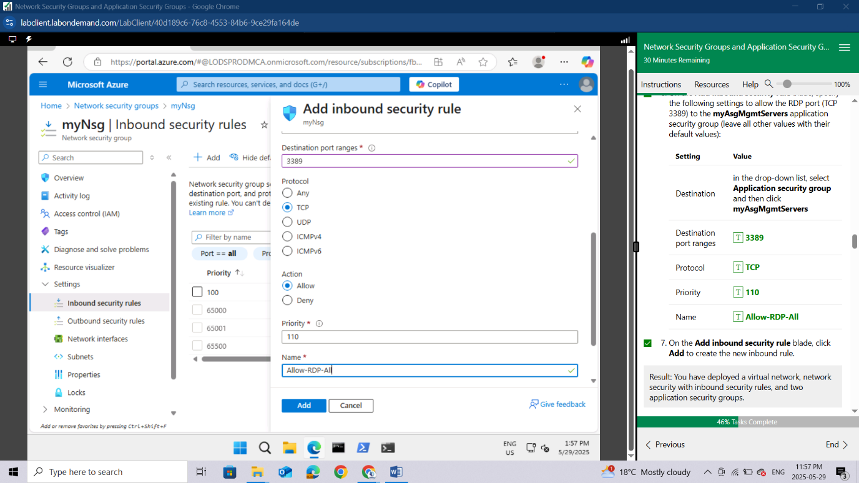

Result: You have deployed a virtual network, network security with inbound security rules, and two application security groups.

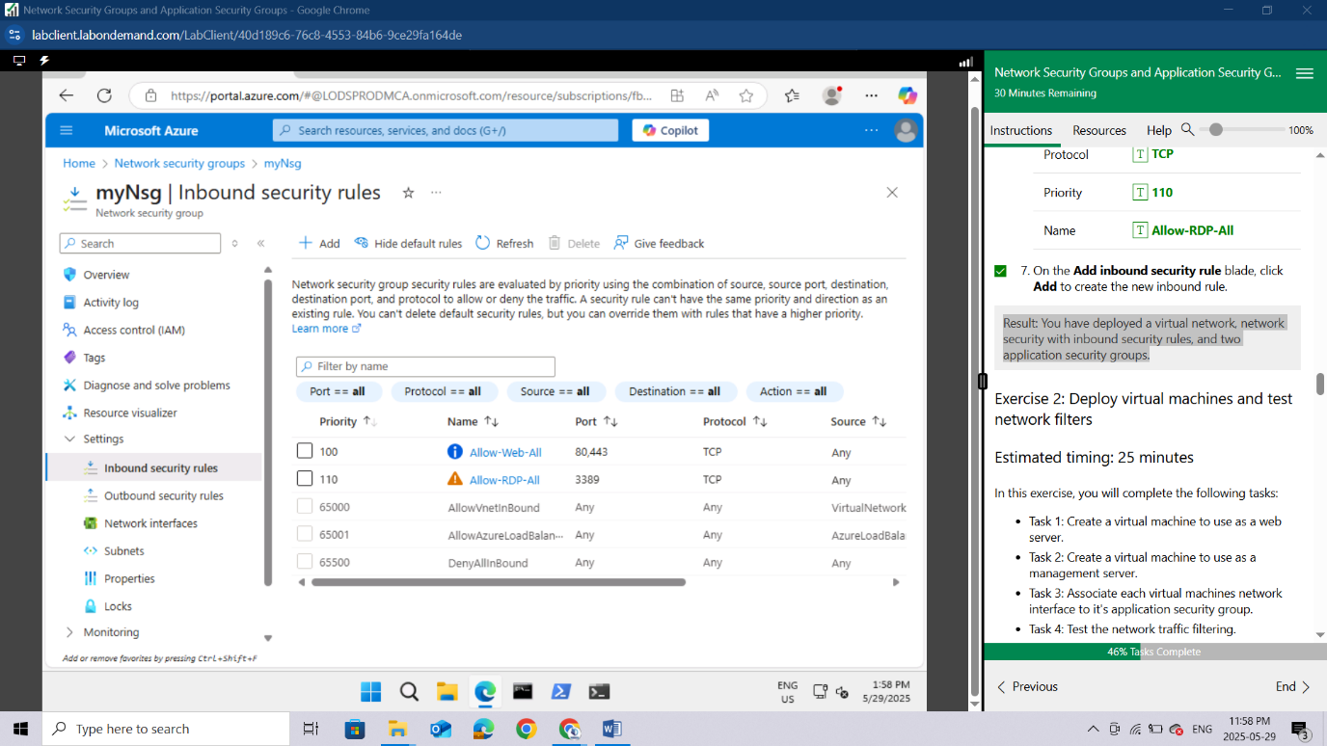

## Exercise 2: Deploy virtual machines and test network filters

Estimated timing: 25 minutes

In this exercise, you will complete the following tasks:

* Task 1: Create a virtual machine to use as a web server.
* Task 2: Create a virtual machine to use as a management server.
* Task 3: Associate each virtual machines network interface to it's application security group.
* Task 4: Test the network traffic filtering.

#### **Task 1: Create a virtual machine to use as a web server.**

In this task, you will create a virtual machine to use as a web server.

In the Azure portal, in the **Search resources, services, and docs** text box at the top of the Azure portal page, type **Virtual machines** and press the **Enter** key.

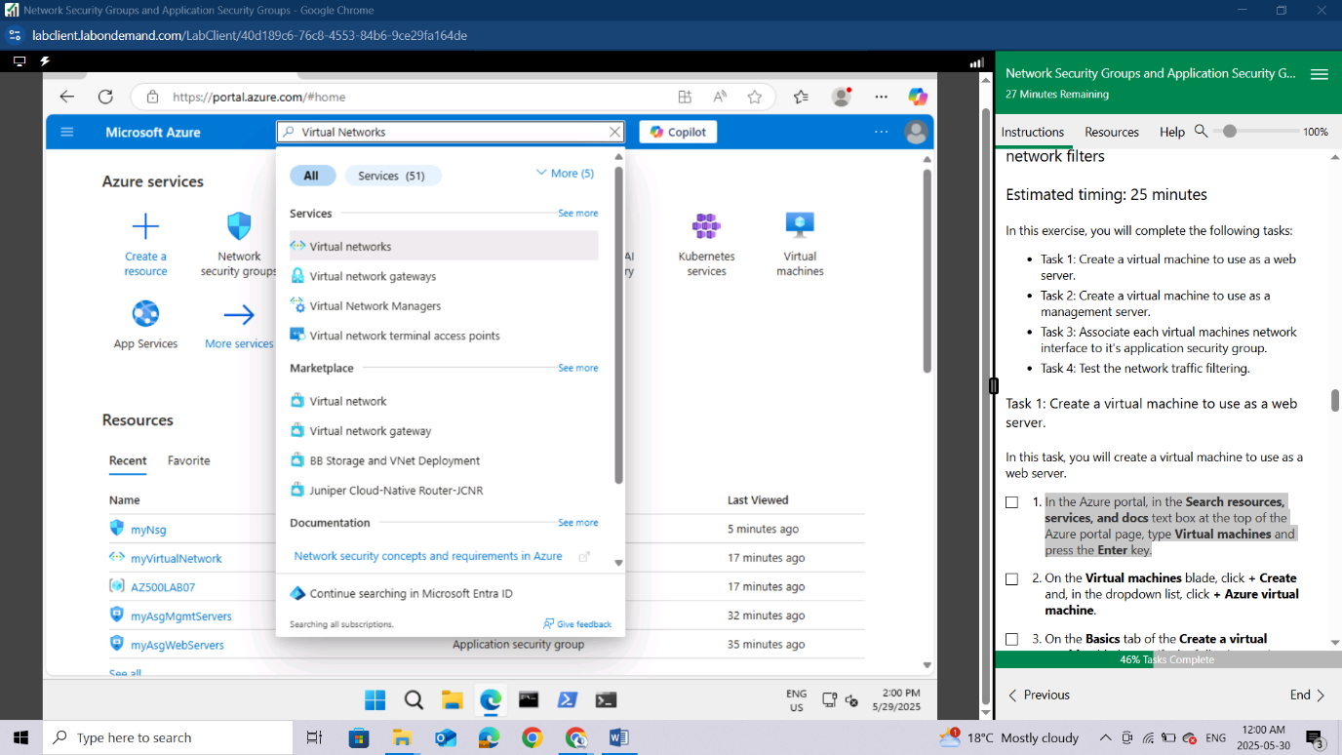

On the **Virtual machines** blade, click **+ Create** and, in the dropdown list, click **+ Azure virtual machine**.

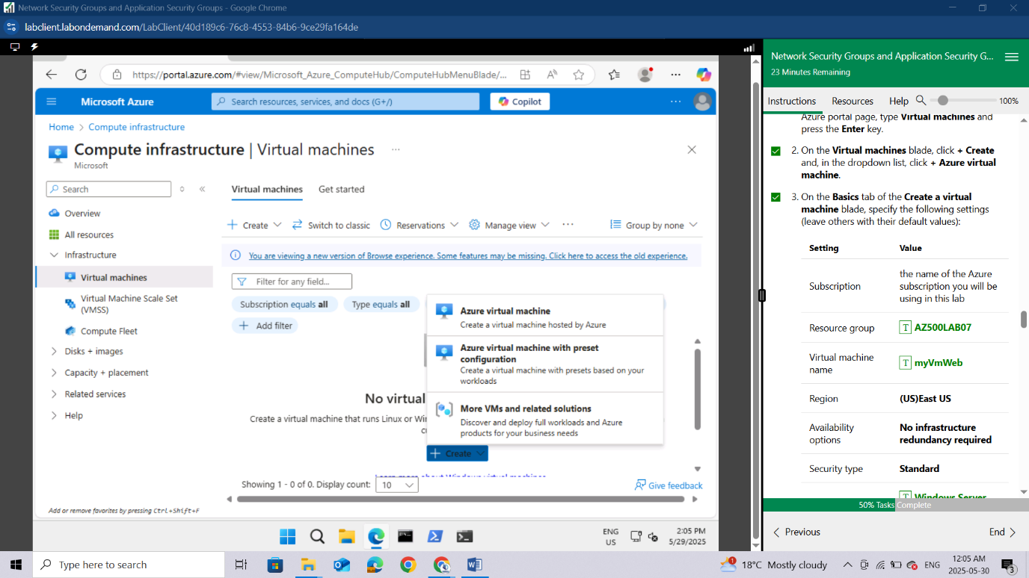

On the **Basics** tab of the **Create a virtual machine** blade, specify the following settings (leave others with their default values):

| **Setting** | **Value** |
| --- | --- |
| Subscription | the name of the Azure subscription you will be using in this lab |
| Resource group | **AZ500LAB07** |
| Virtual machine name | **myVmWeb** |
| Region | **(US)East US** |
| Availability options | **No infrastructure redundancy required** |
| Security type | **Standard** |
| Image | **Windows Server 2022 Datacenter: Azure Edition- x64 Gen2** |
| Size | **Standard D2s v3** |
| Username | **Student** |
| Password | **Please create your own password and record it for future reference in subsequent labs** |
| Confirm password | **Retype your password** |
| Public inbound ports | **None** |
| Would you like to use an existing Windows Server License | **No** |

For public inbound ports, we will rely on the precreated NSG.

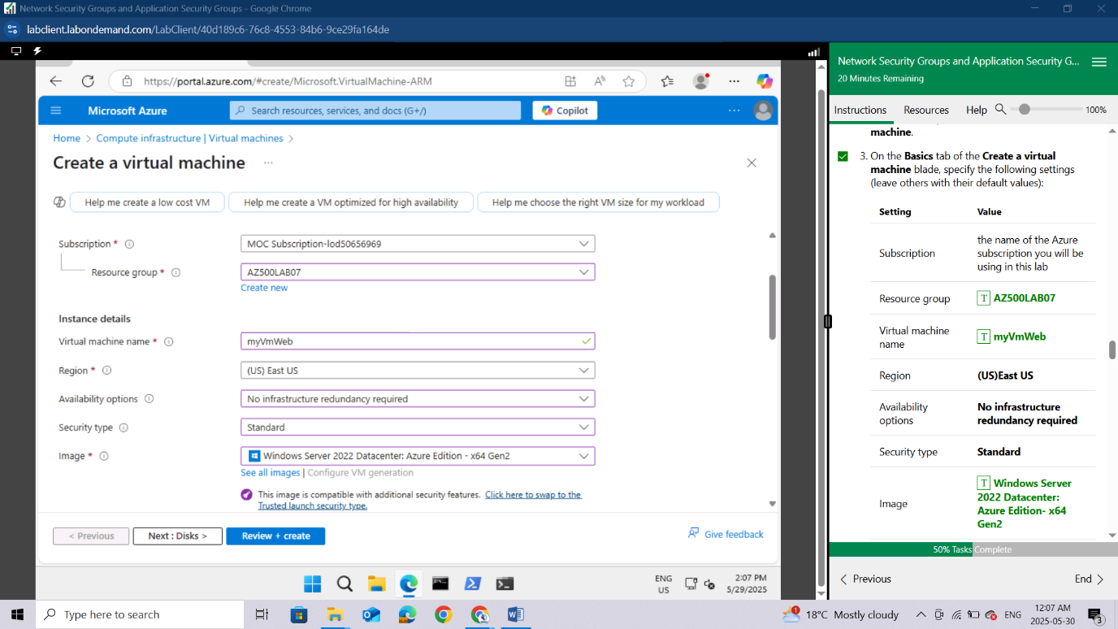

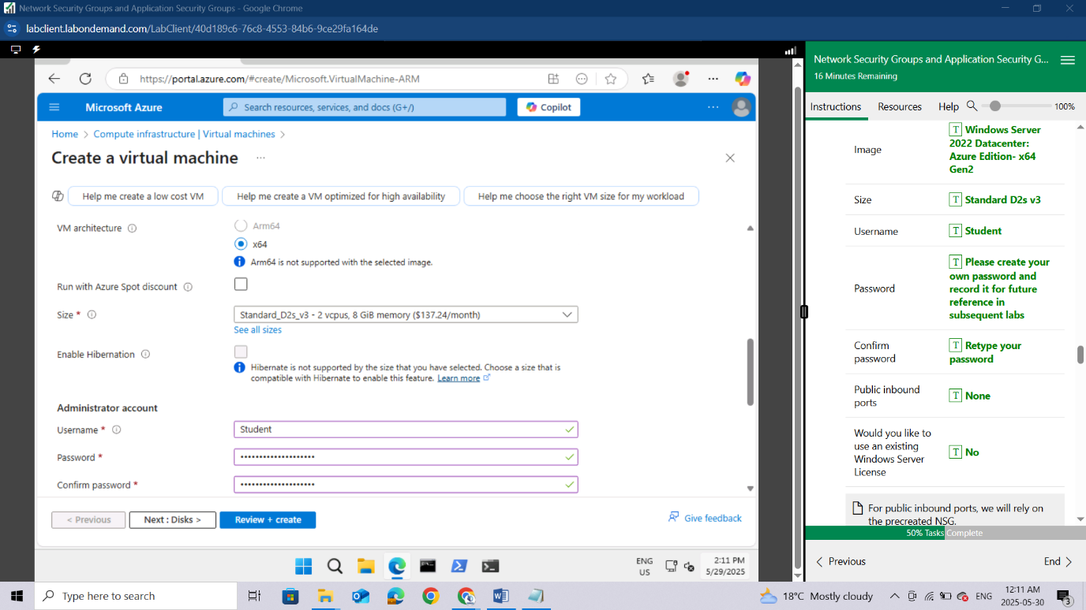

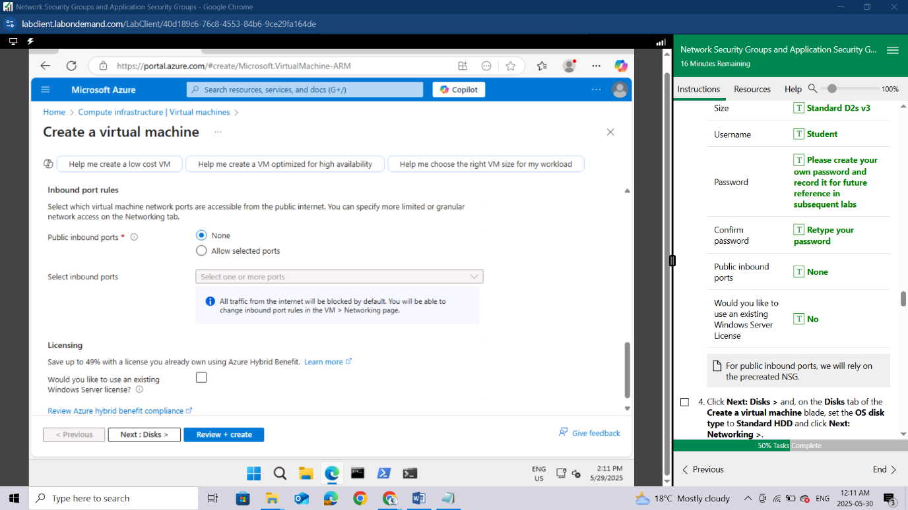

Click **Next: Disks >** and, on the **Disks** tab of the **Create a virtual machine** blade, set the **OS disk type** to **Standard HDD** and click **Next: Networking >**.

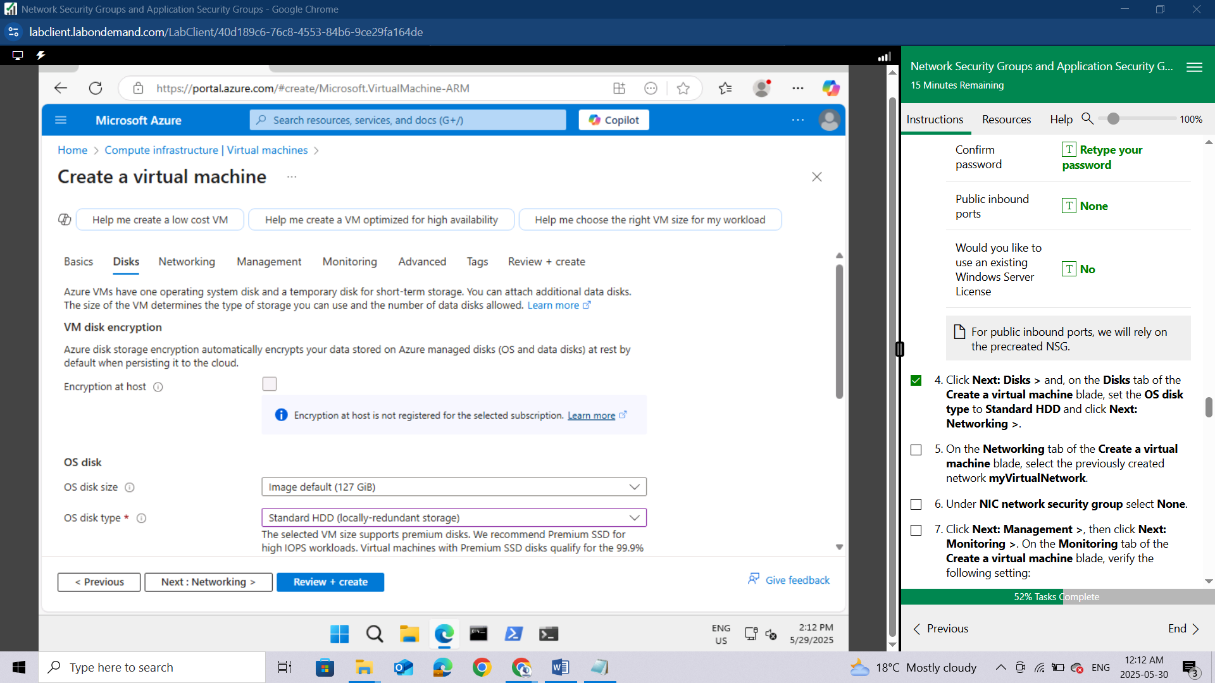

On the **Networking** tab of the **Create a virtual machine** blade, select the previously created network **myVirtualNetwork**.

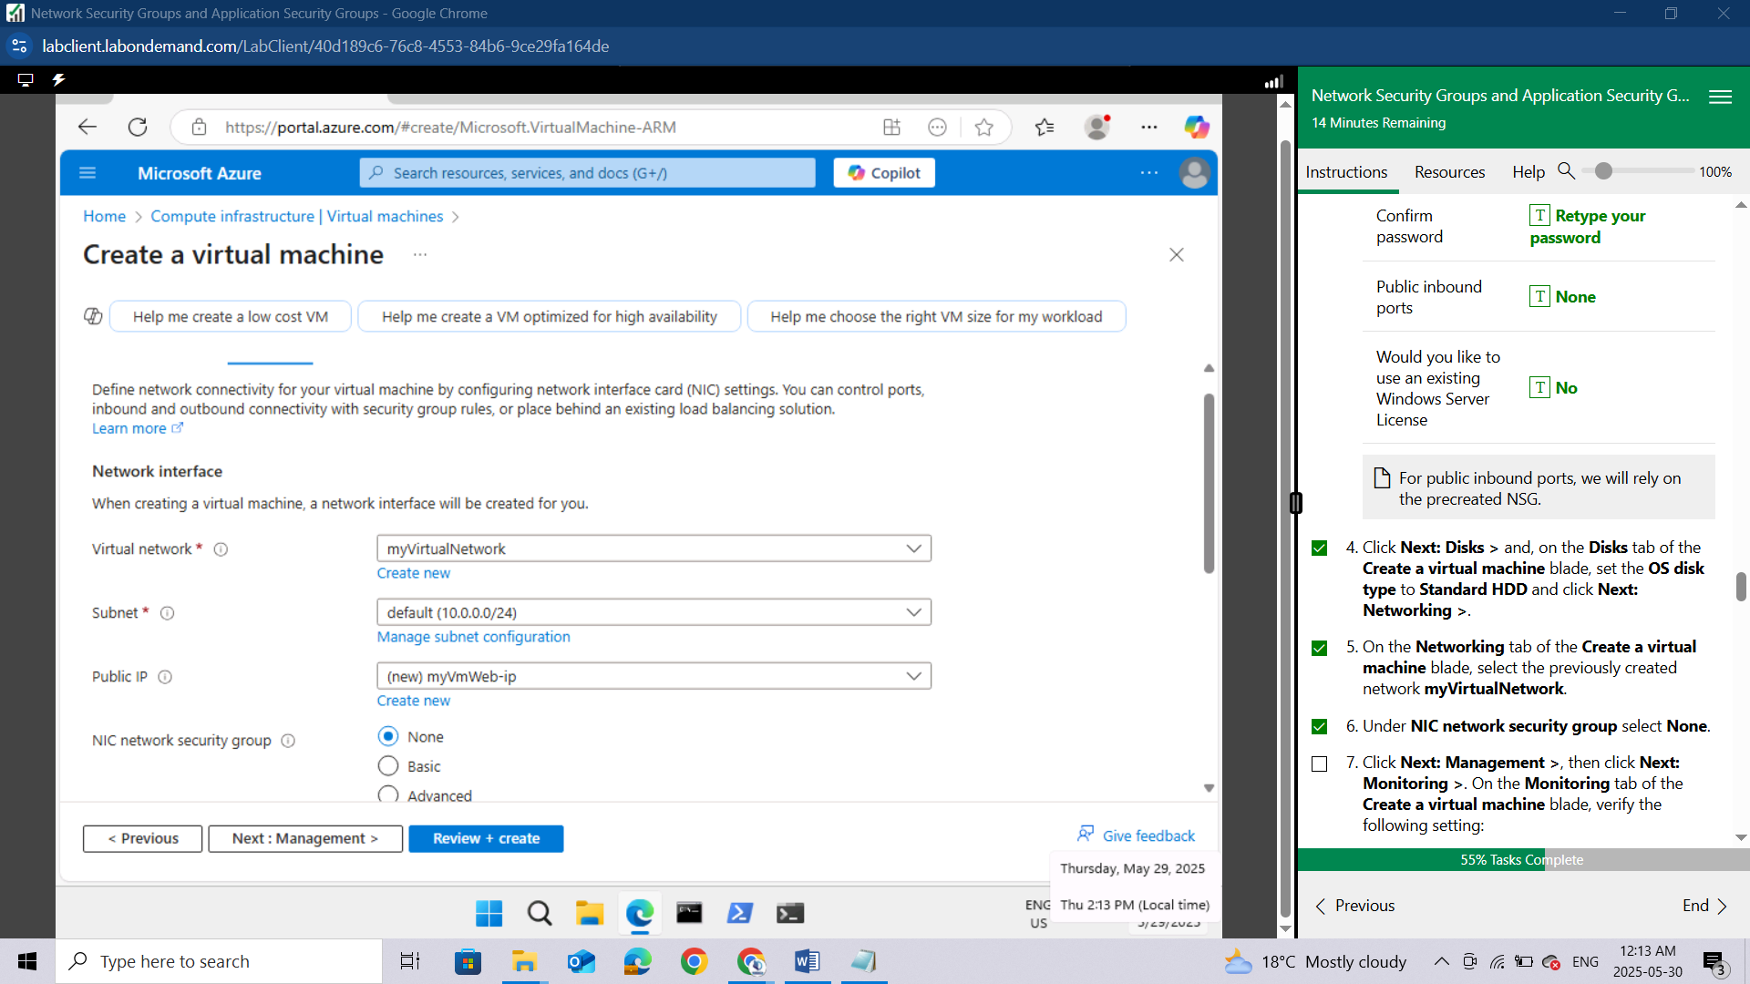

Click **Next: Management >**, then click **Next: Monitoring >**. On the **Monitoring** tab of the **Create a virtual machine** blade, verify the following setting:

| **Setting** | **Value** |
| --- | --- |
| Boot diagnostics | **Enabled with managed storage account (recommended)** |

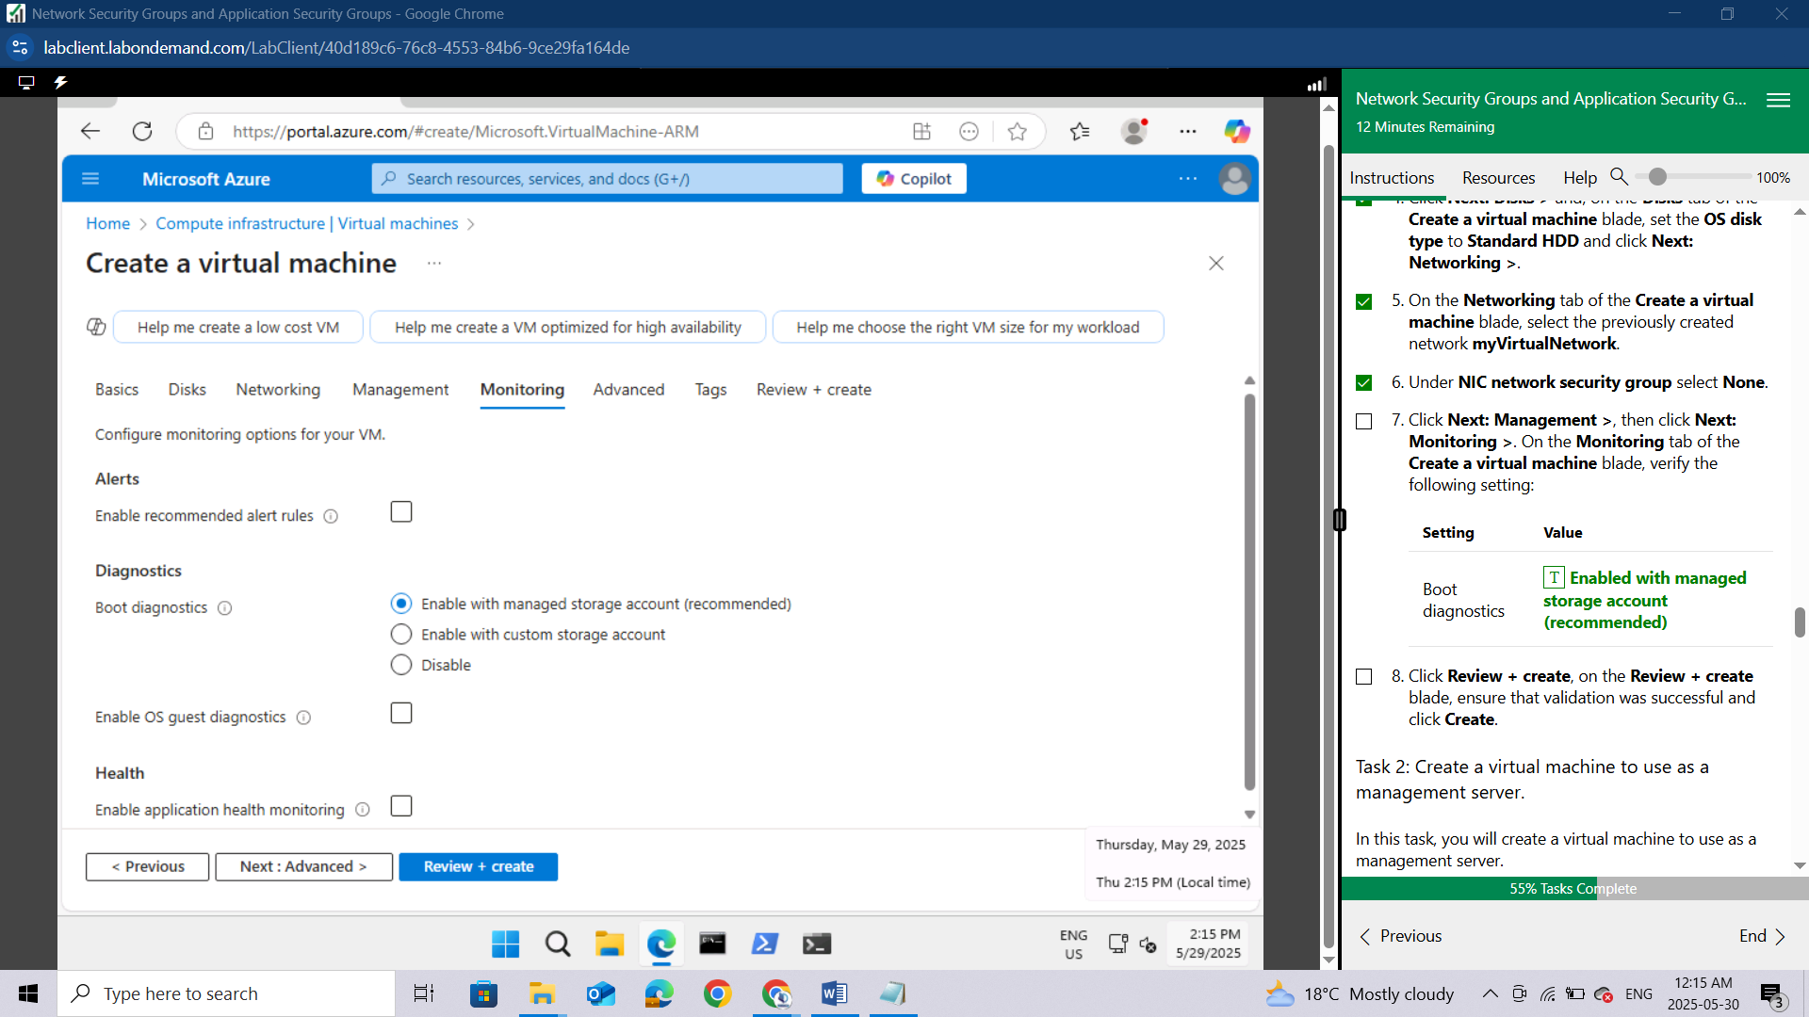

Click **Review + create**, on the **Review + create** blade, ensure that validation was successful and click **Create**.

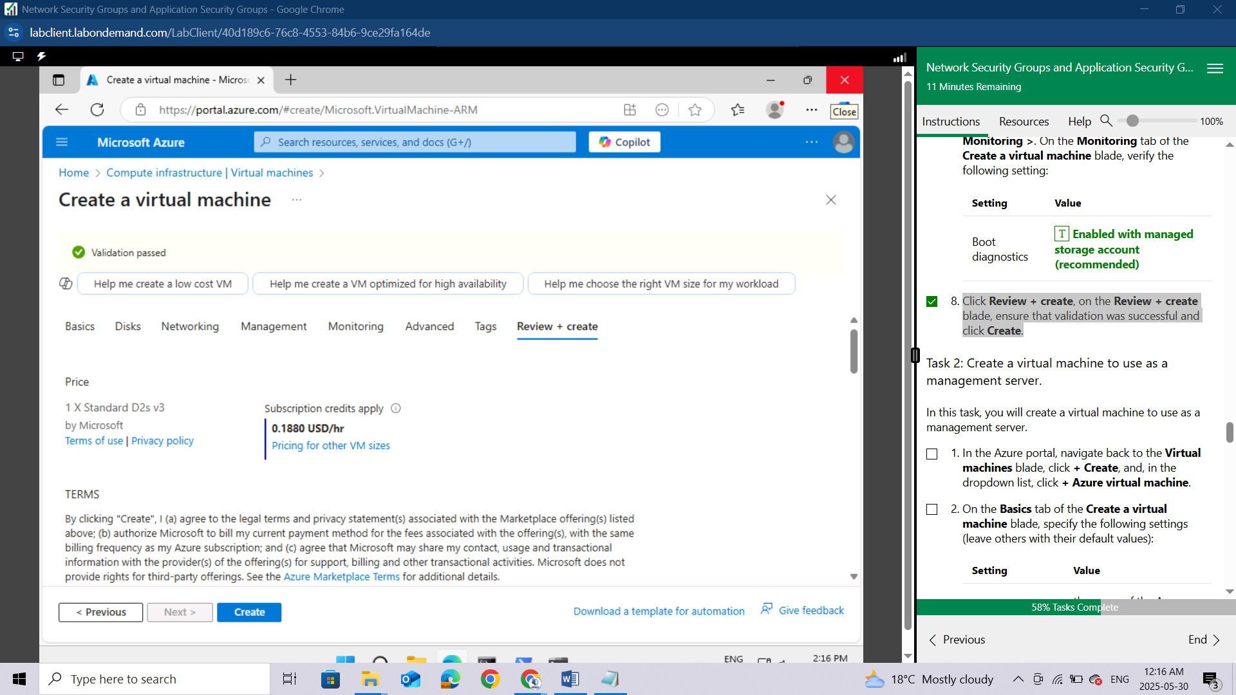

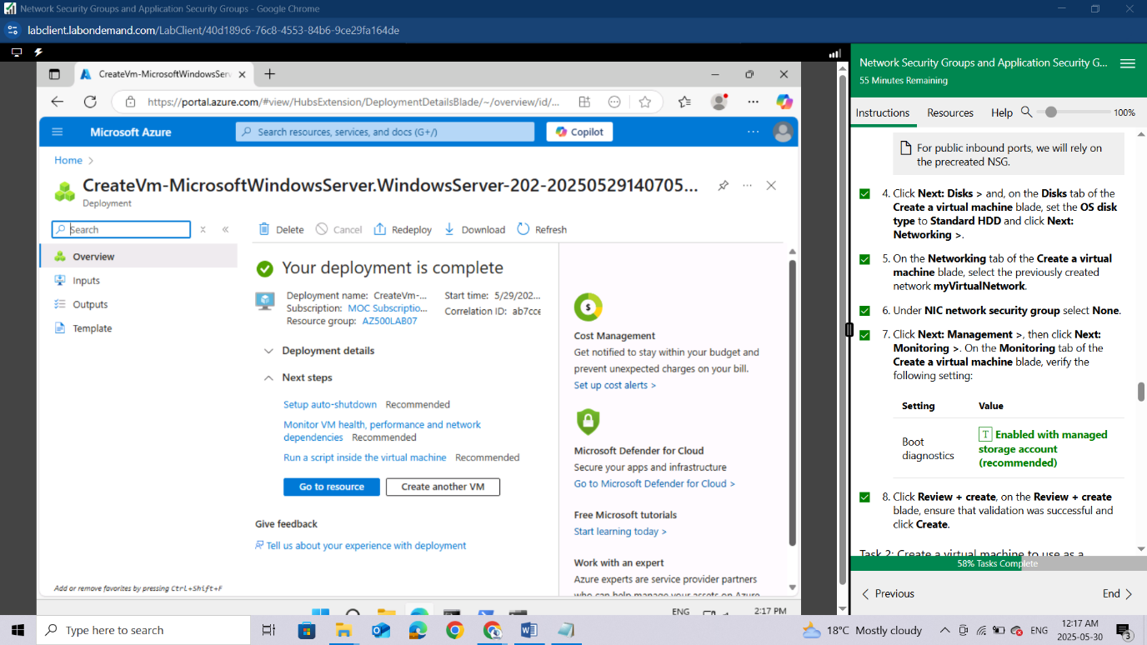

#### **Task 2: Create a virtual machine to use as a management server.**

In this task, you will create a virtual machine to use as a management server.

In the Azure portal, navigate back to the **Virtual machines** blade, click **+ Create**, and, in the dropdown list, click **+ Azure virtual machine**.

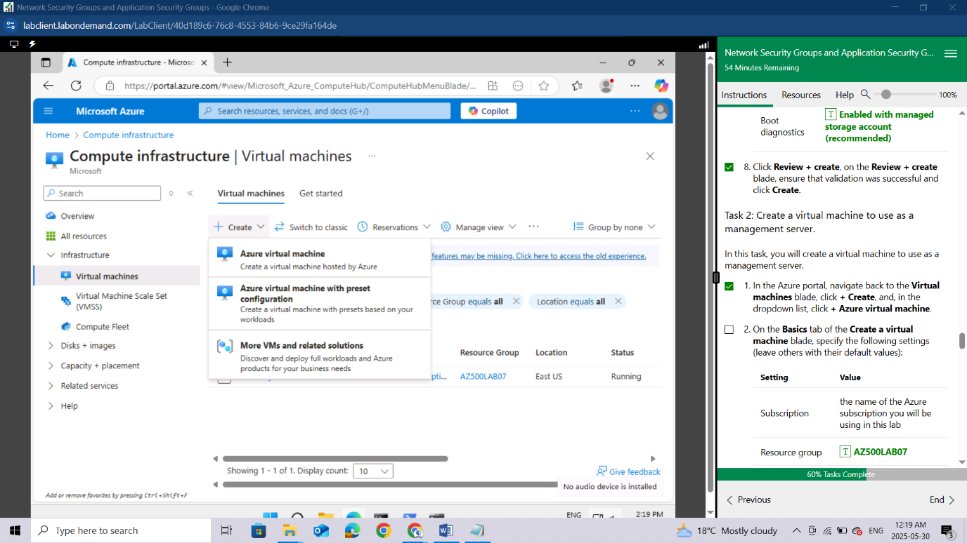

On the **Basics** tab of the **Create a virtual machine** blade, specify the following settings (leave others with their default values):

| **Setting** | **Value** |
| --- | --- |
| Subscription | the name of the Azure subscription you will be using in this lab |
| Resource group | **AZ500LAB07** |
| Virtual machine name | **myVMMgmt** |
| Region | (US)East US |
| Image | **Windows Server 2022 Datacenter: Azure Edition - x64 Gen2** |
| Size | **Standard D2s v3** |
| Username | **Student** |
| Password | **Please use your personal password created in Lab 02 > Exercise 2 > Task 1 > Step 3.** |
| Public inbound ports | **None** |
| Already have a Windows Server license | **No** |

For public inbound ports, we will rely on the precreated NSG.

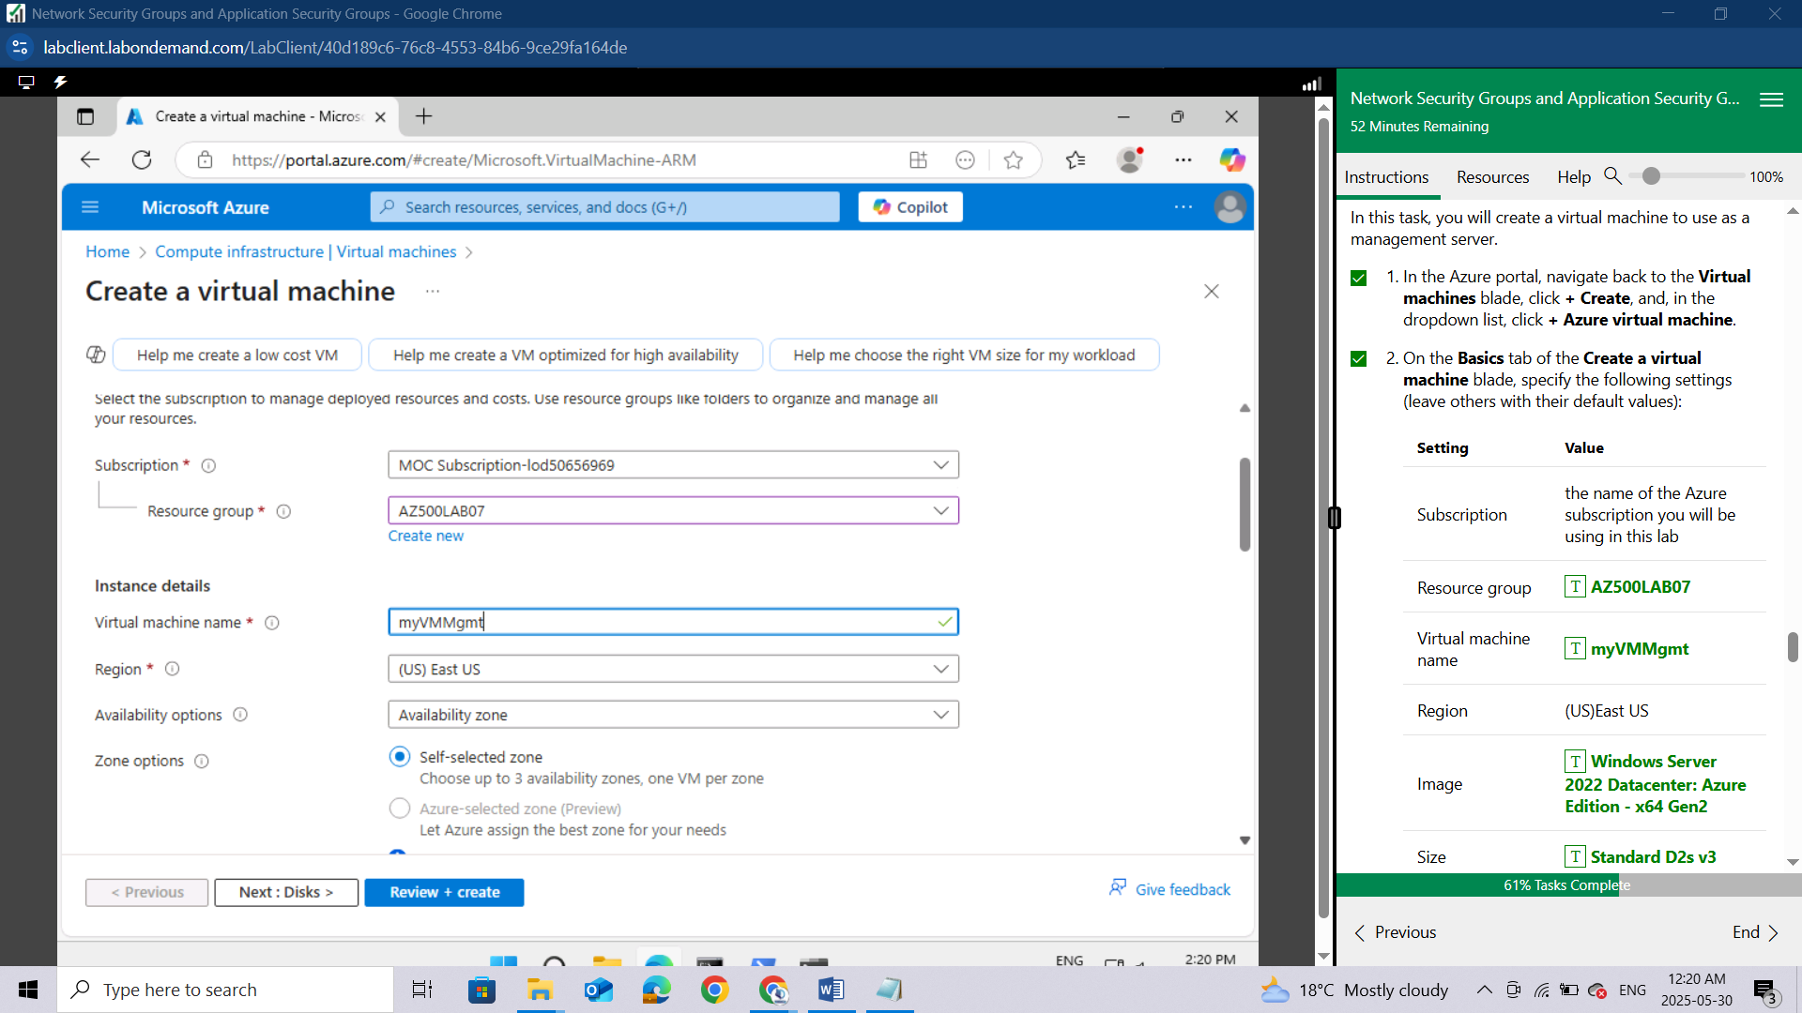

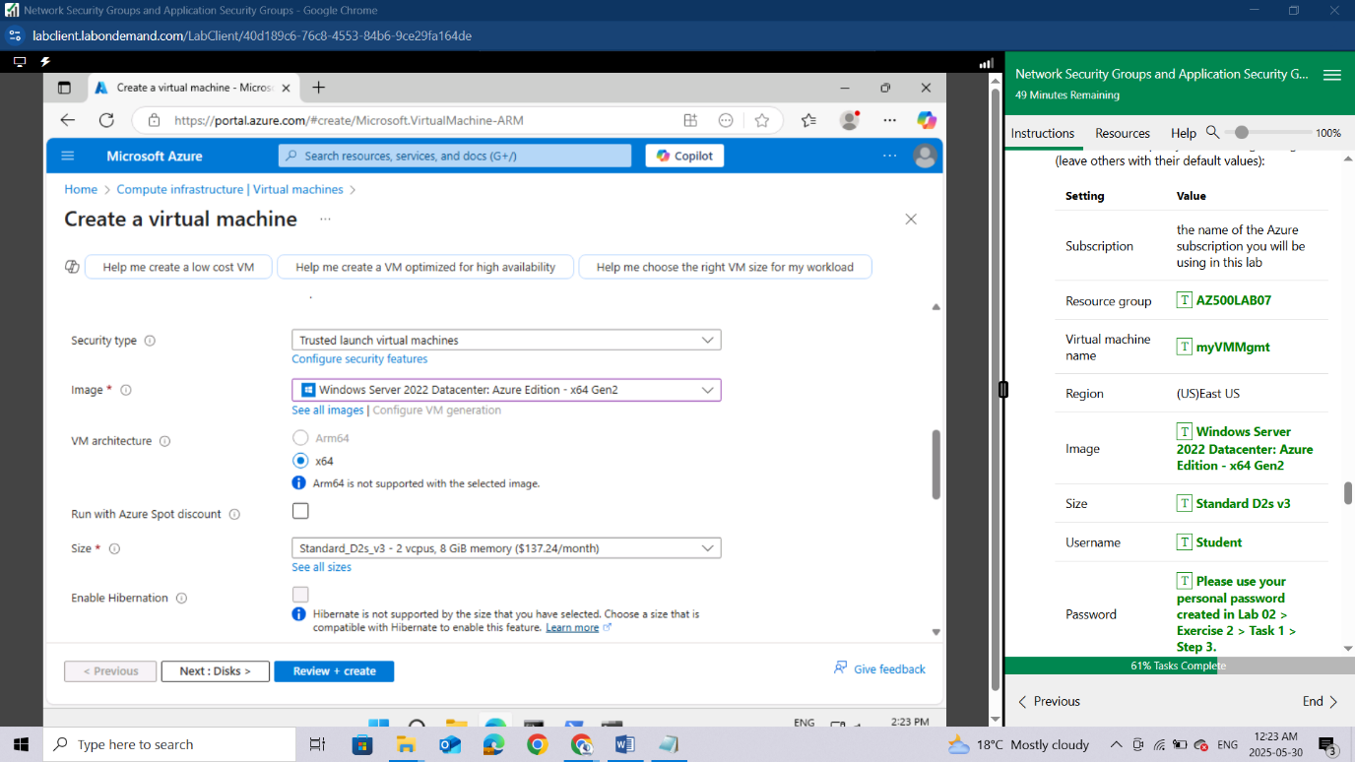

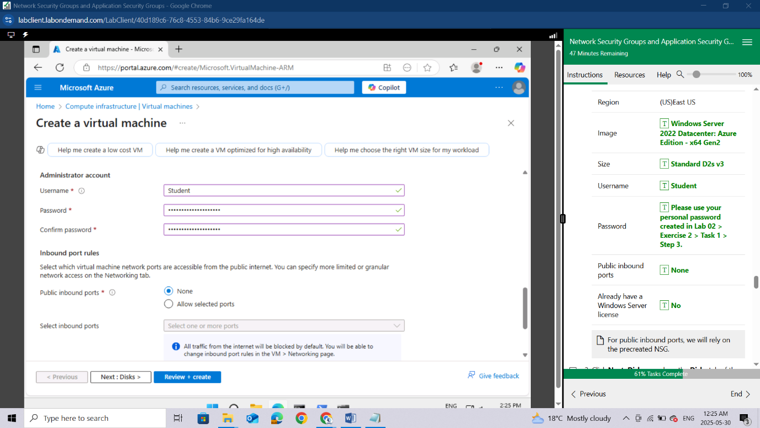

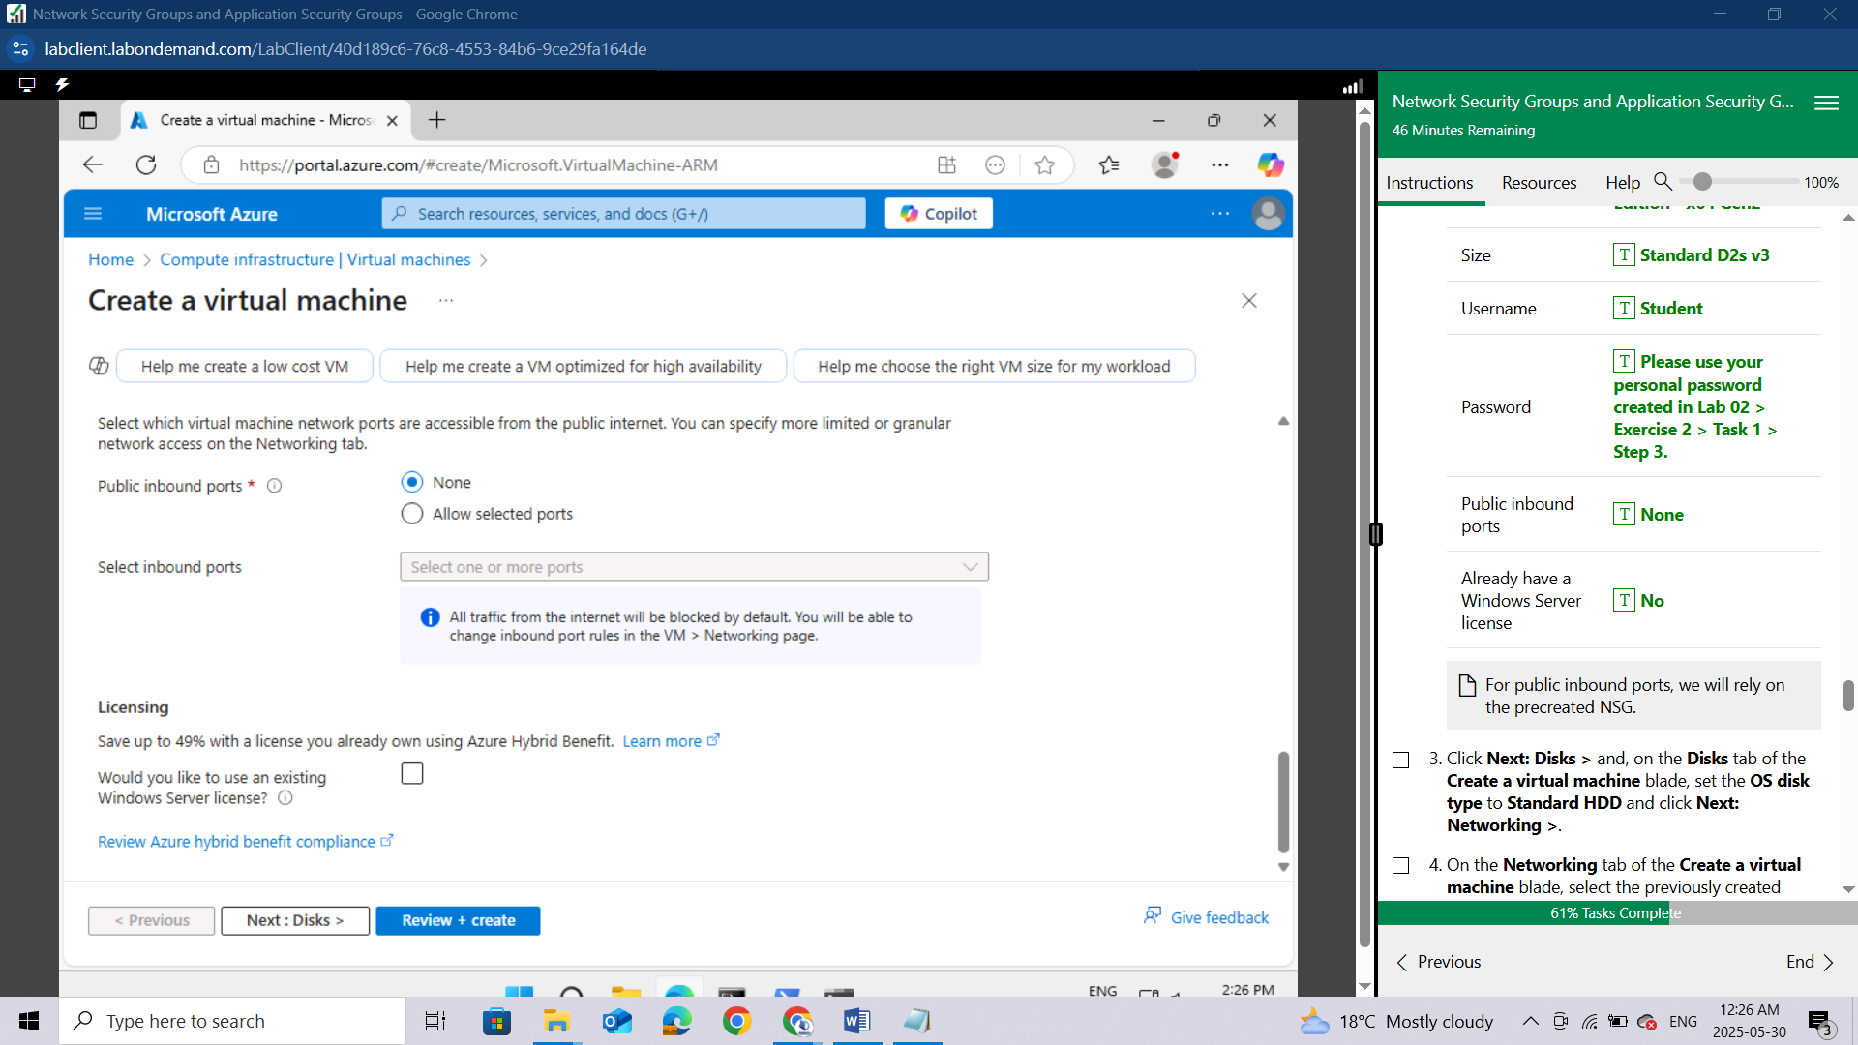

Click **Next: Disks >** and, on the **Disks** tab of the **Create a virtual machine** blade, set the **OS disk type** to **Standard HDD** and click **Next: Networking >**.

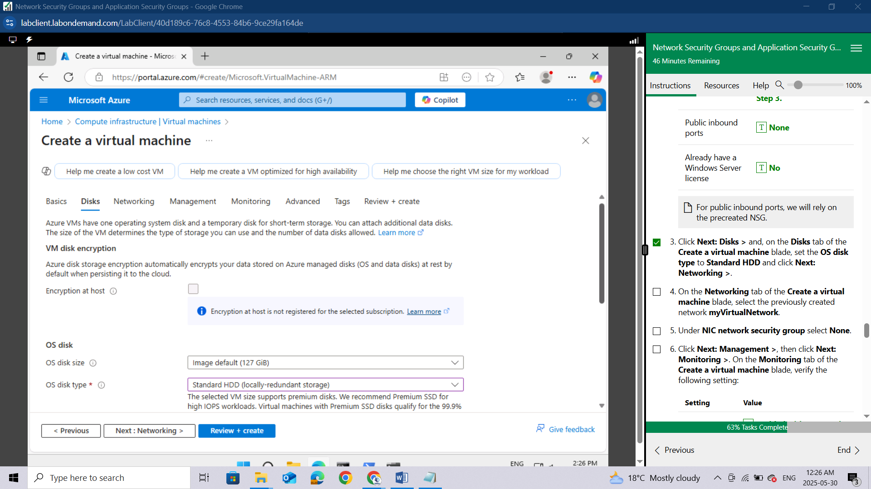

On the **Networking** tab of the **Create a virtual machine** blade, select the previously created network **myVirtualNetwork**.

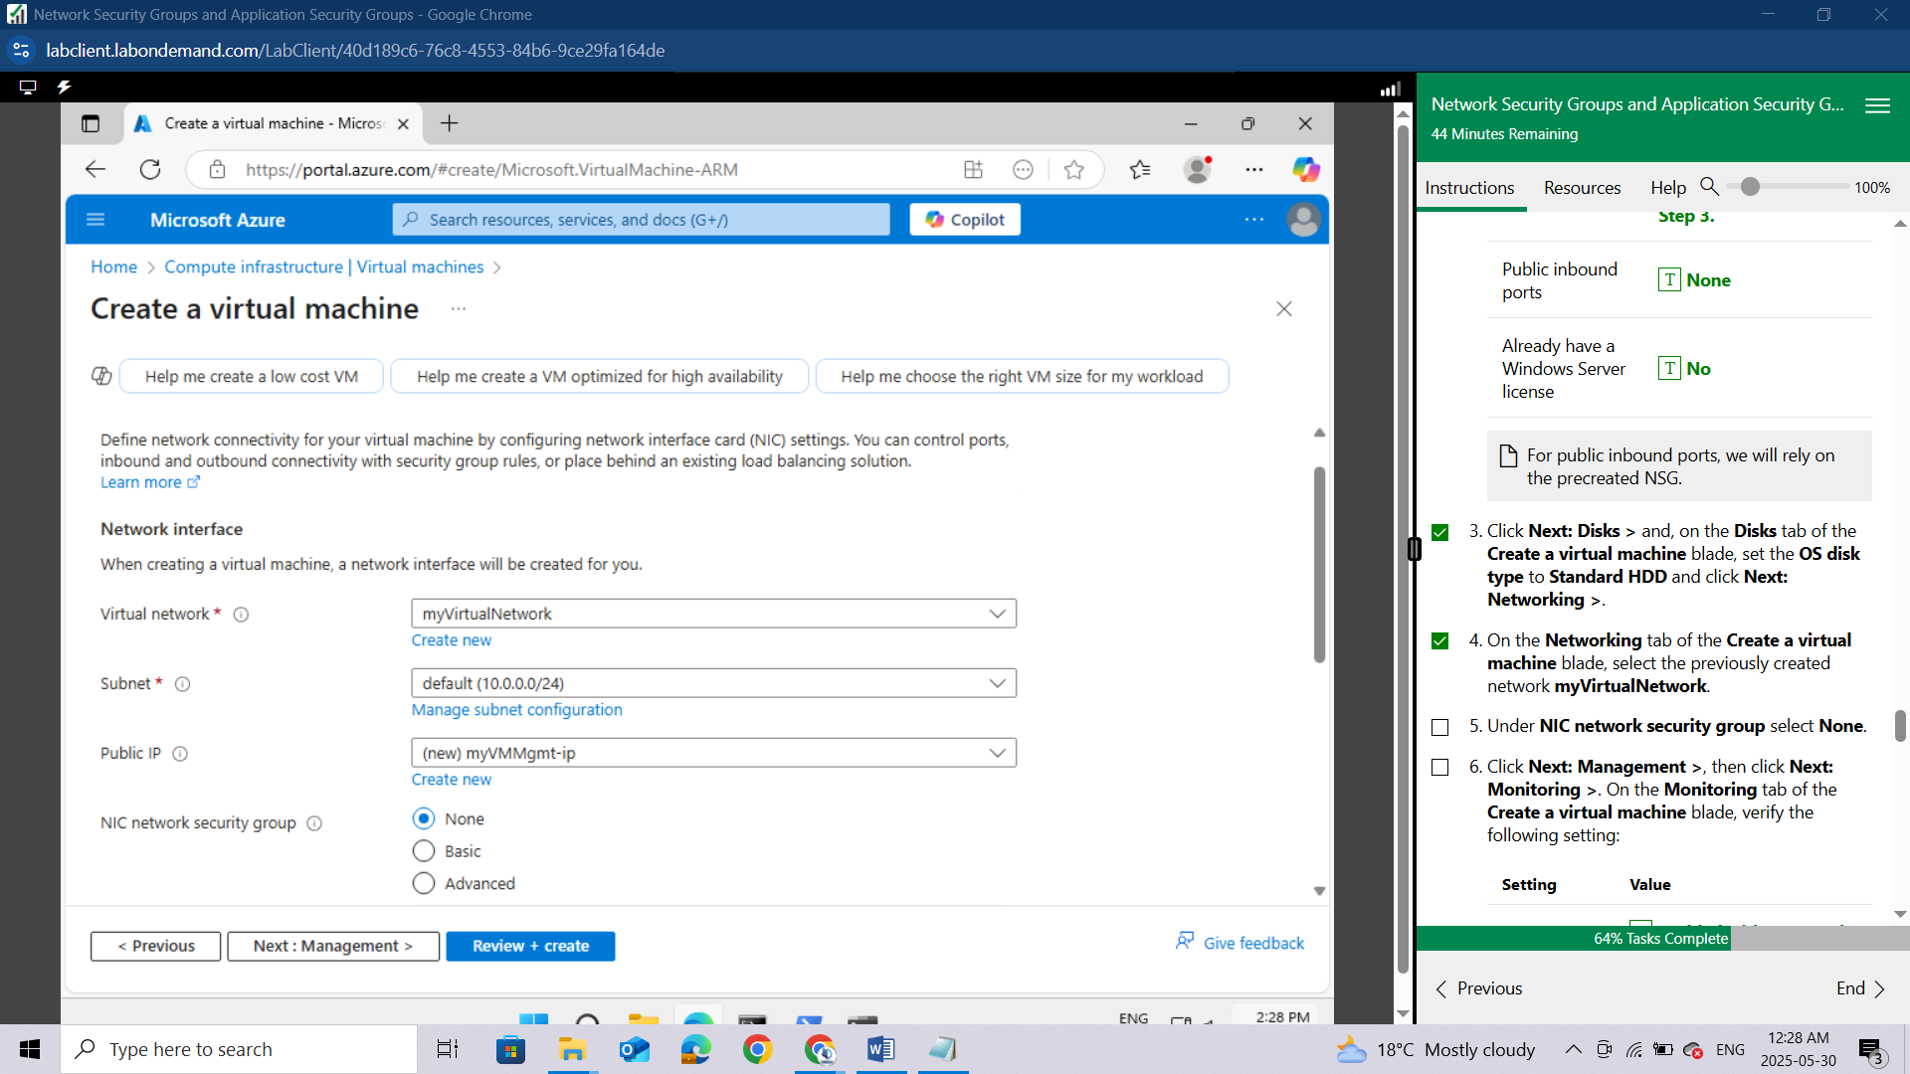

Click **Next: Management >**, then click **Next: Monitoring >**. On the **Monitoring** tab of the **Create a virtual machine** blade, verify the following setting:

| **Setting** | **Value** |
| --- | --- |
| Boot diagnostics | **Enabled with managed storage account (recommended)** |

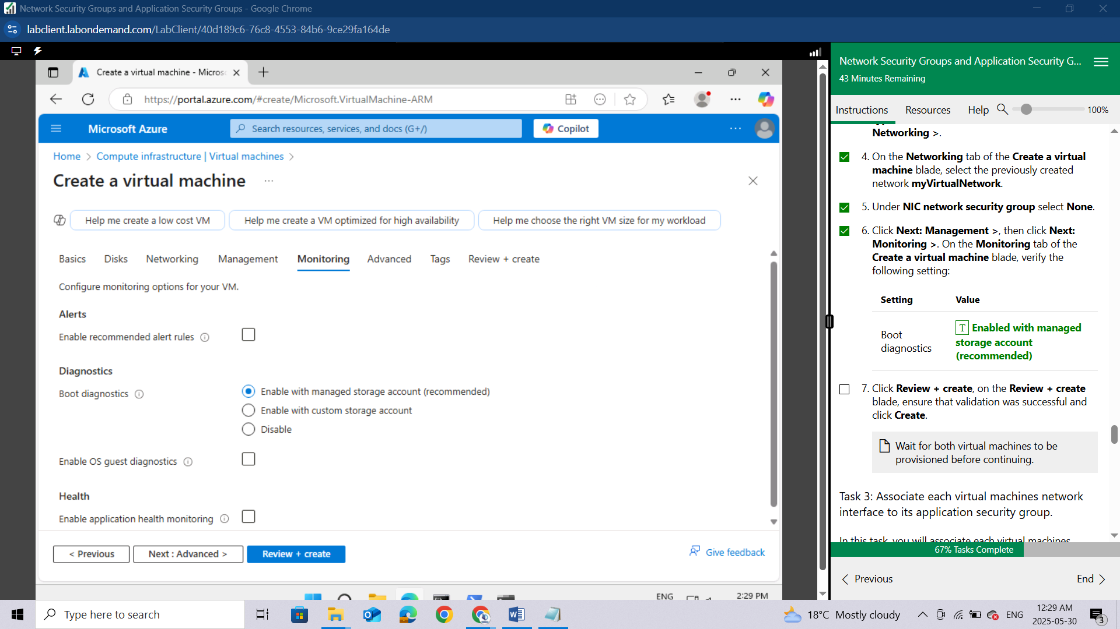

Click **Review + create**, on the **Review + create** blade, ensure that validation was successful and click **Create**.

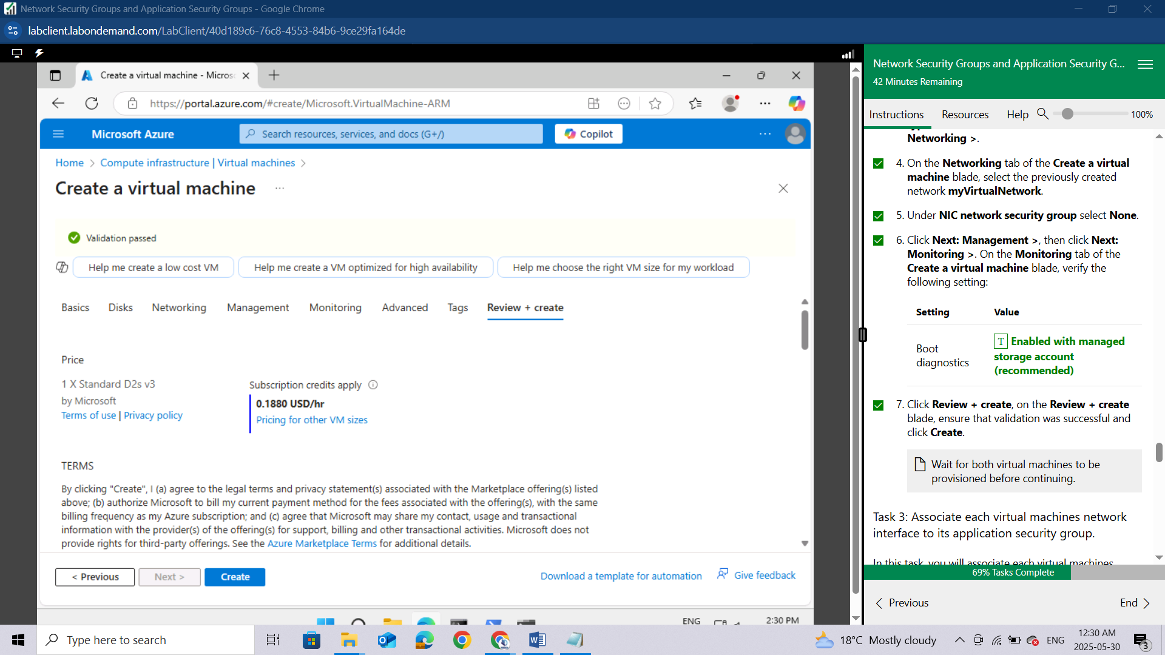

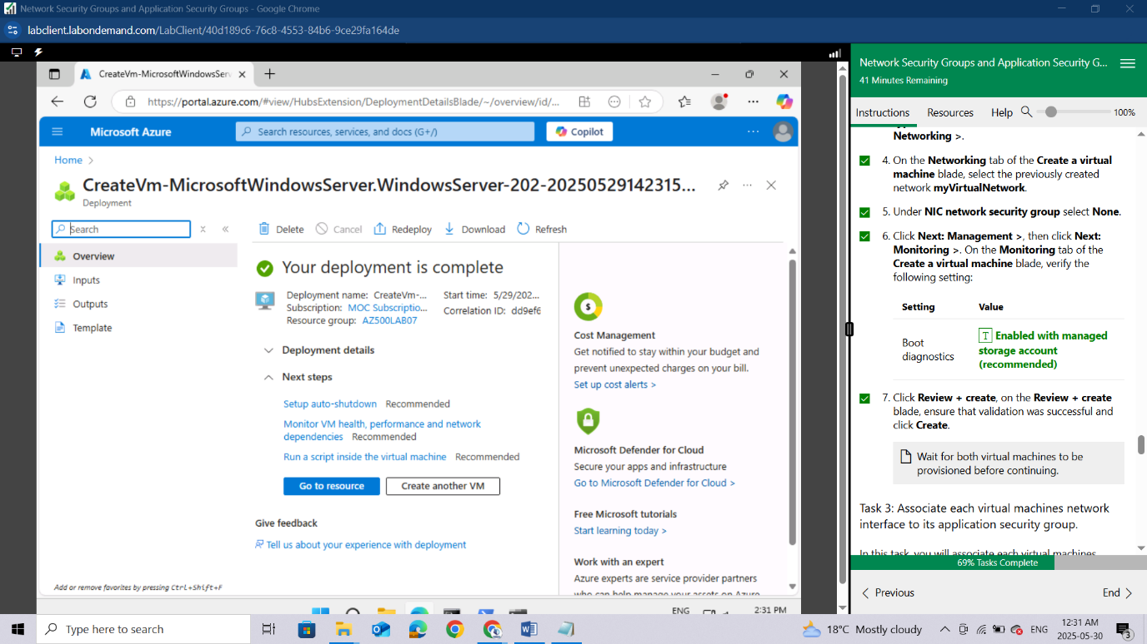

Wait for both virtual machines to be provisioned before continuing.

#### **Task 3: Associate each virtual machines network interface to its application security group.**

In this task, you will associate each virtual machines network interface with the corresponding application security group. The myVMWeb virtual machine interface will be associated to the myAsgWebServers ASG. The myVMMgmt virtual machine interface will be associated to the myAsgMgmtServers ASG.

In the Azure portal, navigate back to the **Virtual machines** blade and verify that both virtual machines are listed with the **Running** status.

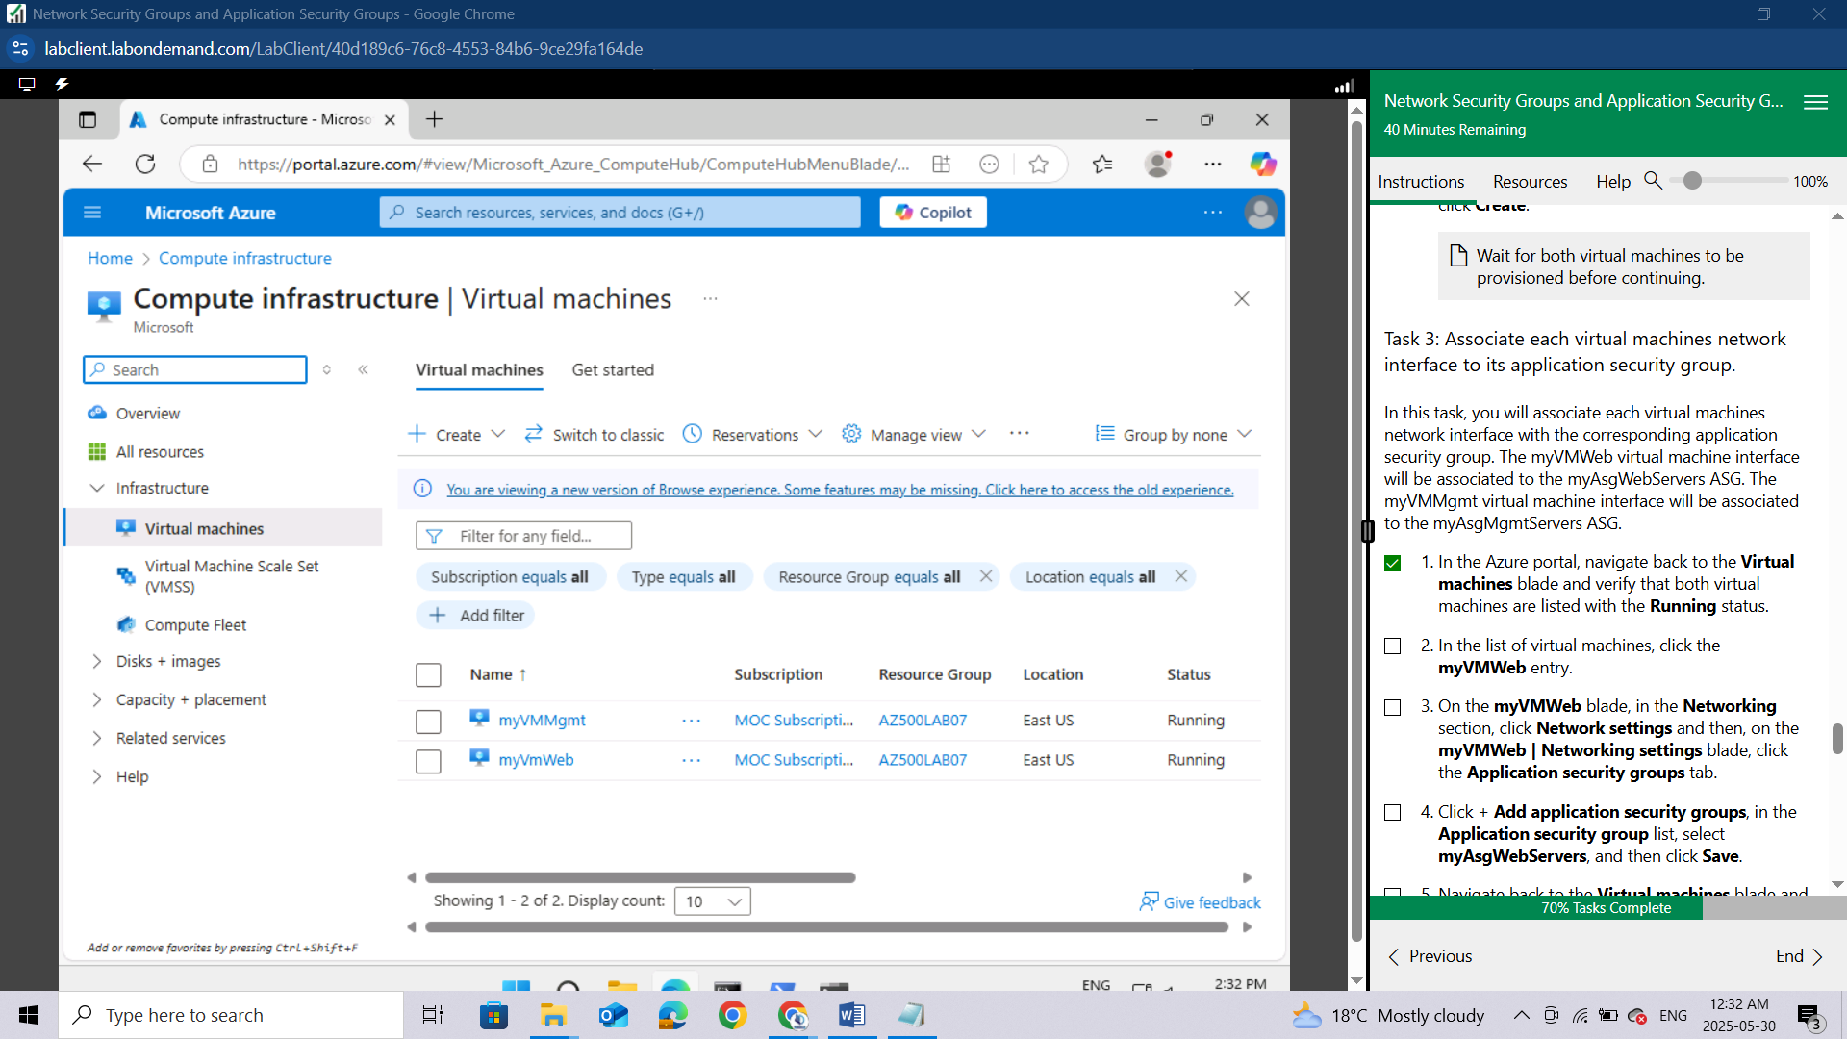

In the list of virtual machines, click the **myVMWeb** entry.

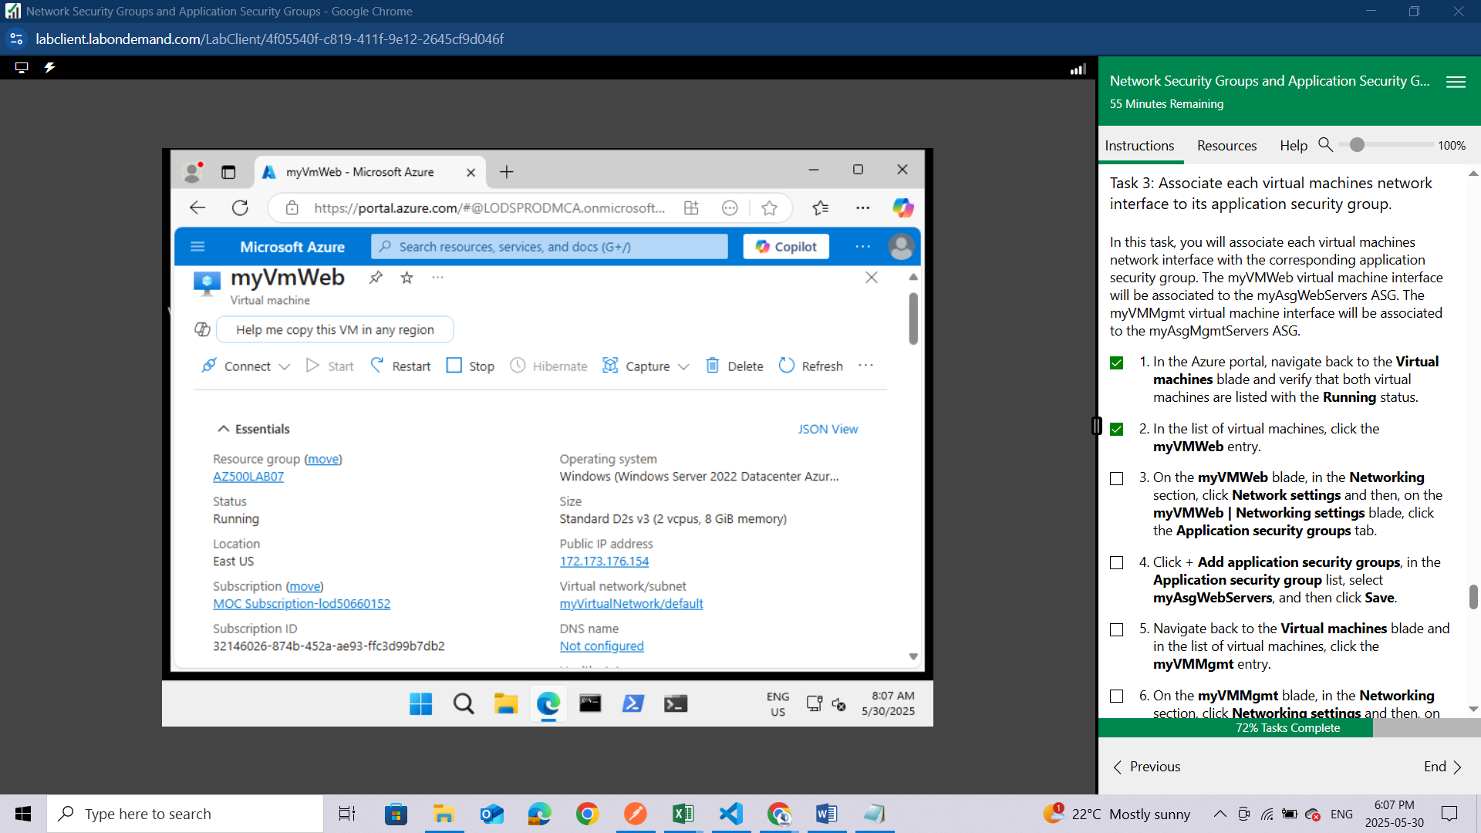

On the **myVMWeb** blade, in the **Networking** section, click **Network settings** and then, on the **myVMWeb | Networking settings** blade, click the **Application security groups** tab.

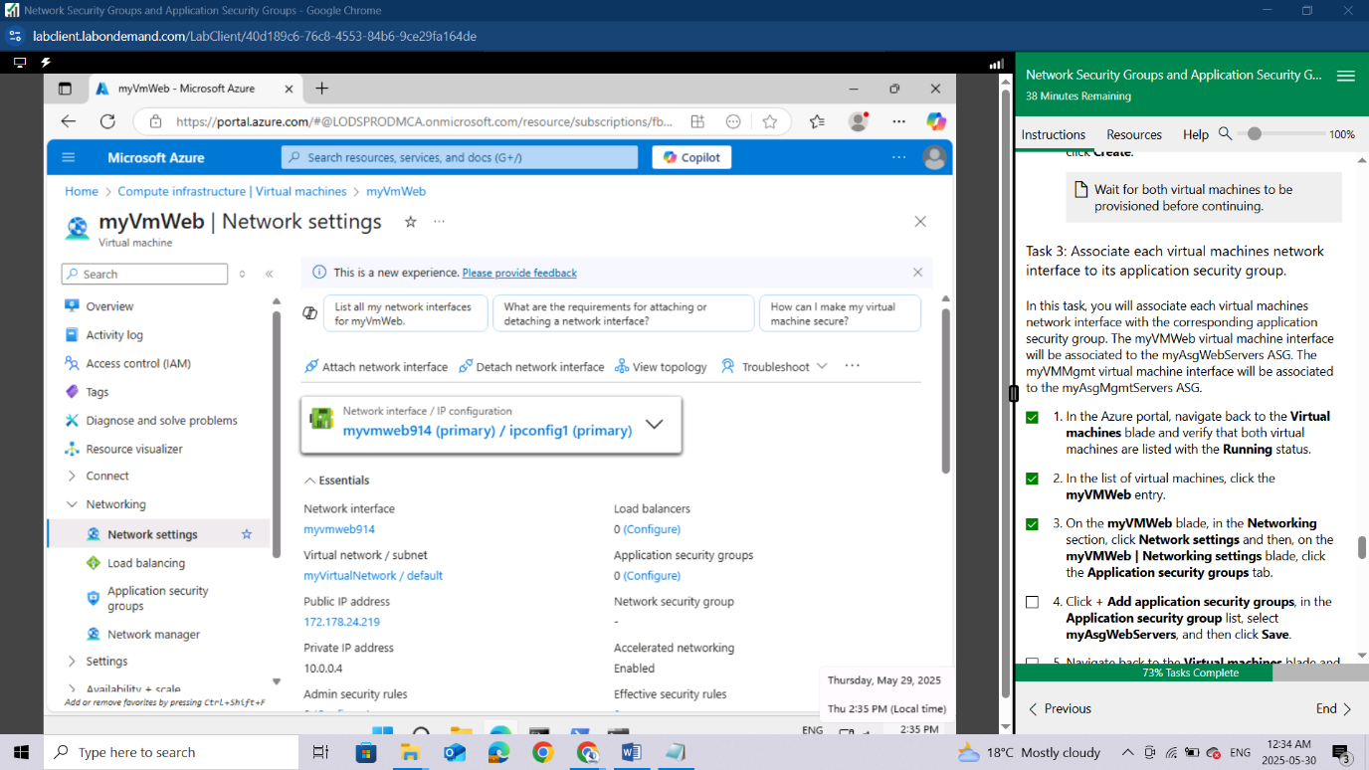

Click + **Add application security groups**, in the **Application security group** list,

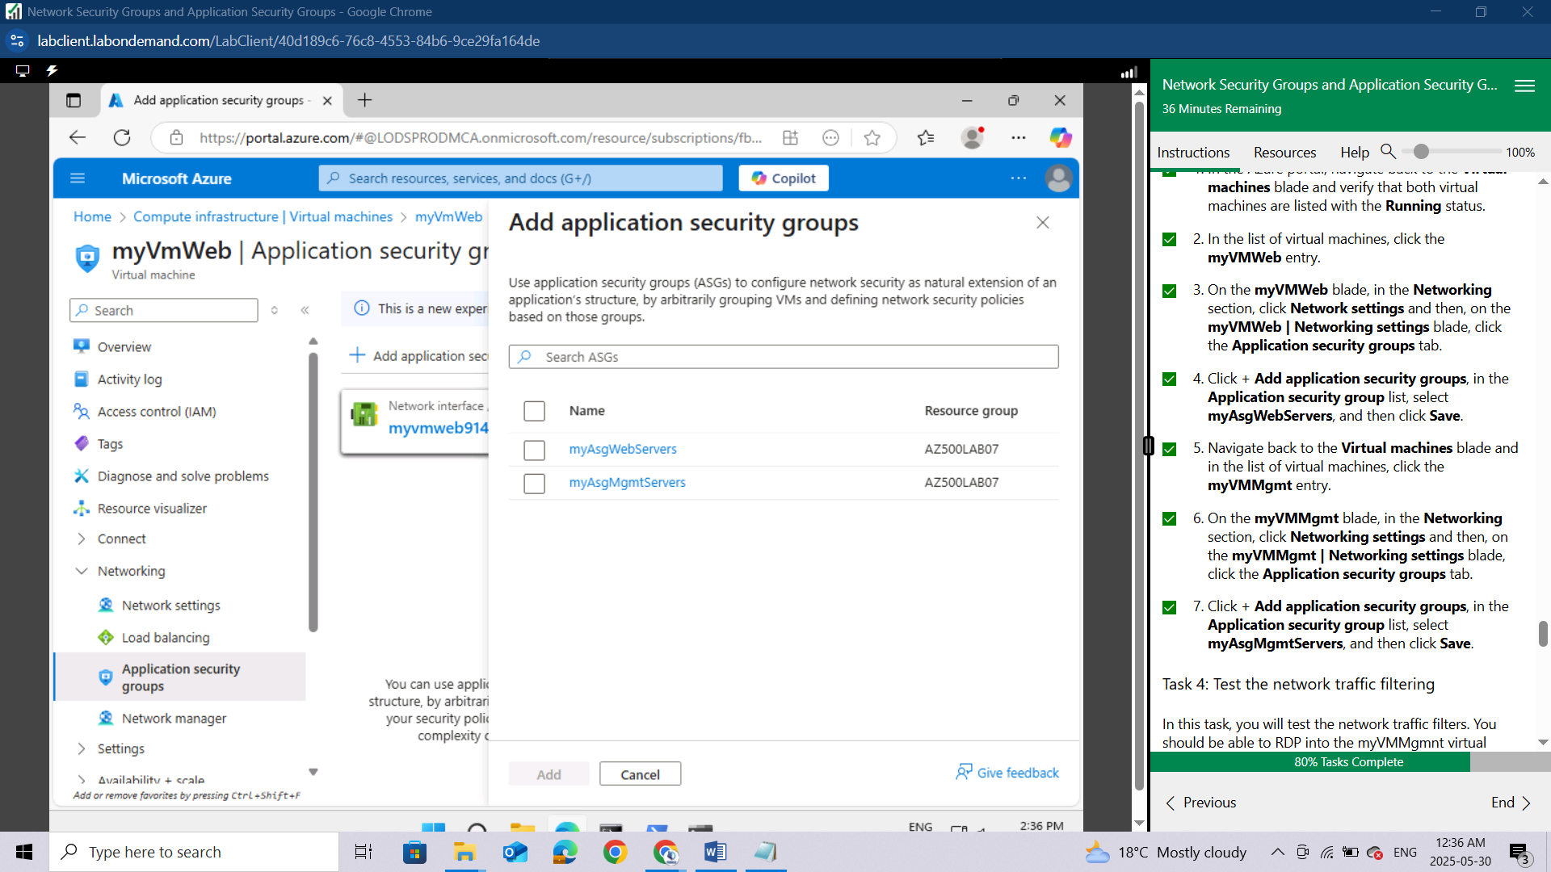

select **myAsgWebServers**, and then click **Add**.

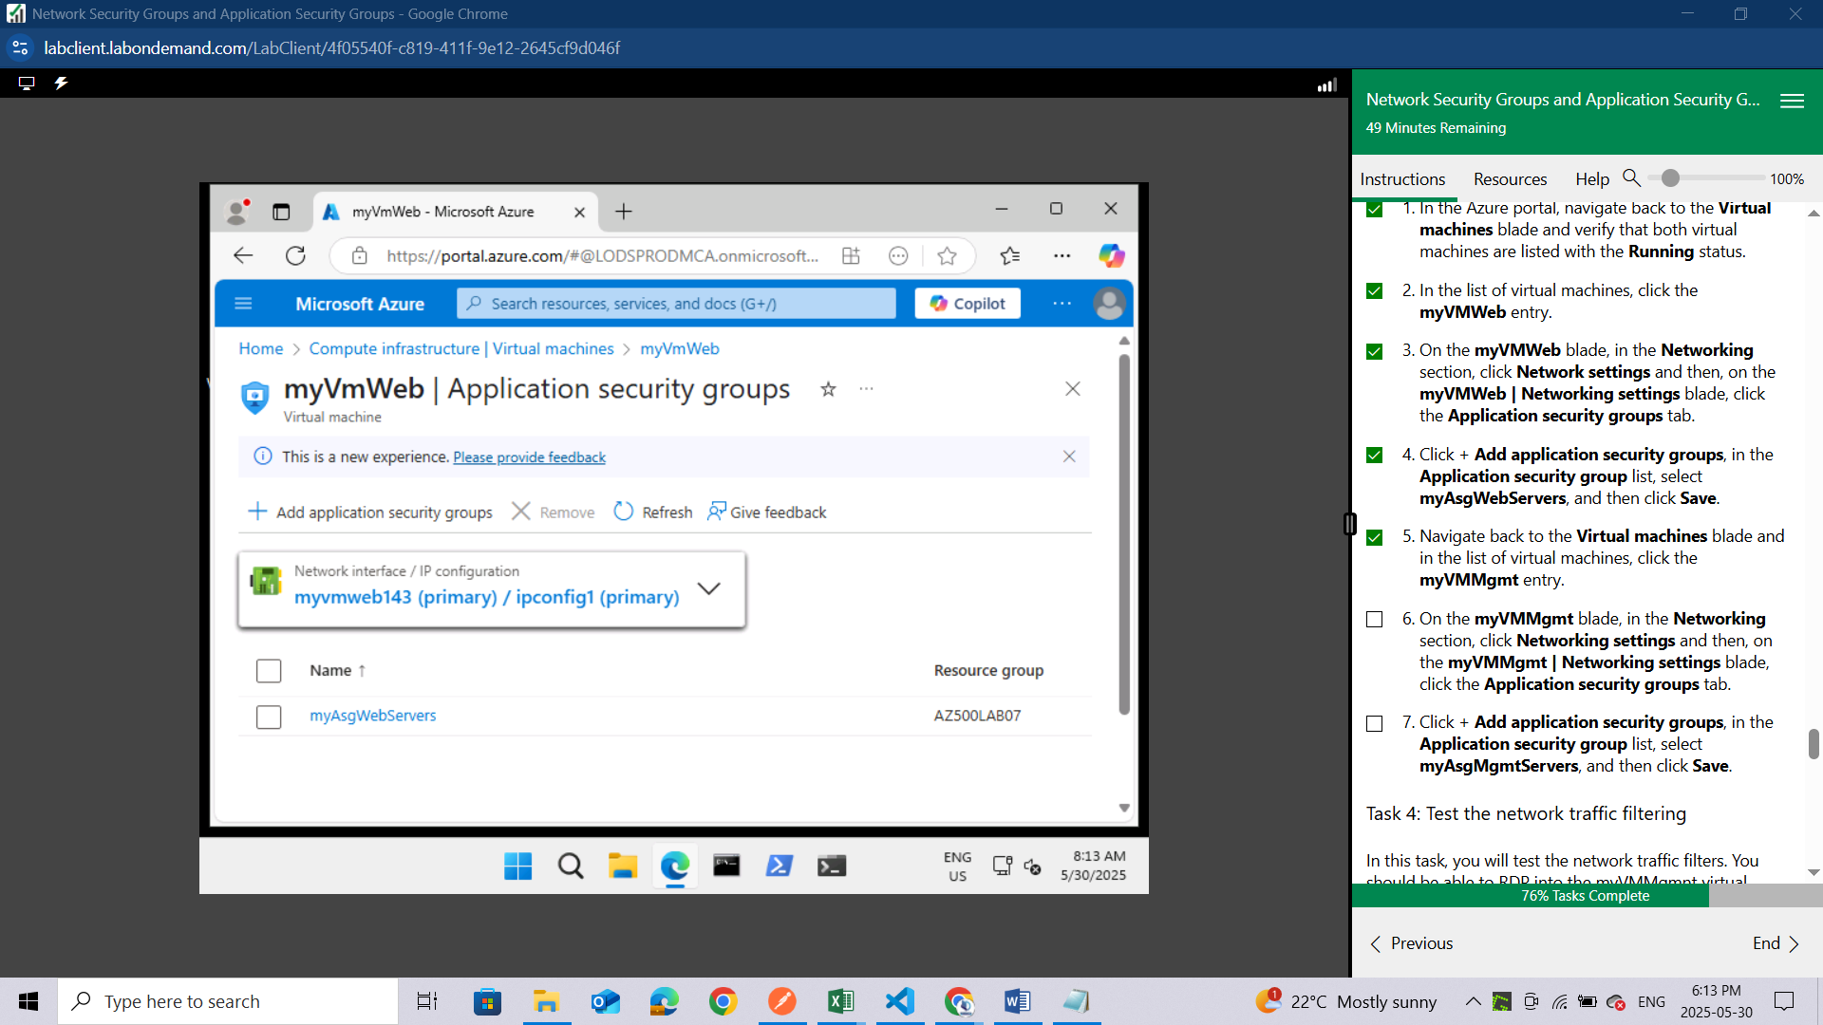

Navigate back to the **Virtual machines** blade and in the list of virtual machines, click the **myVMMgmt** entry.

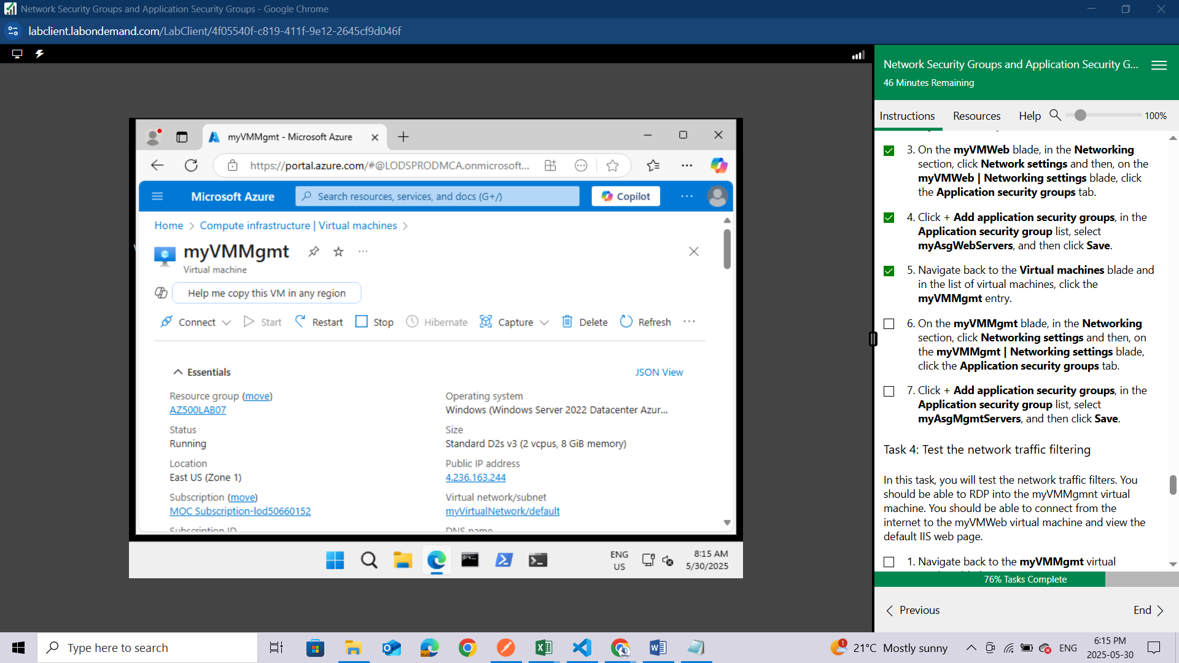

On the **myVMMgmt** blade, in the **Networking** section, click **Networking settings** and then, on the **myVMMgmt | Networking settings** blade, click the **Application security groups** tab.

Click + **Add application security groups**, in the **Application security group** list, select **myAsgMgmtServers**, and then click **Add.**

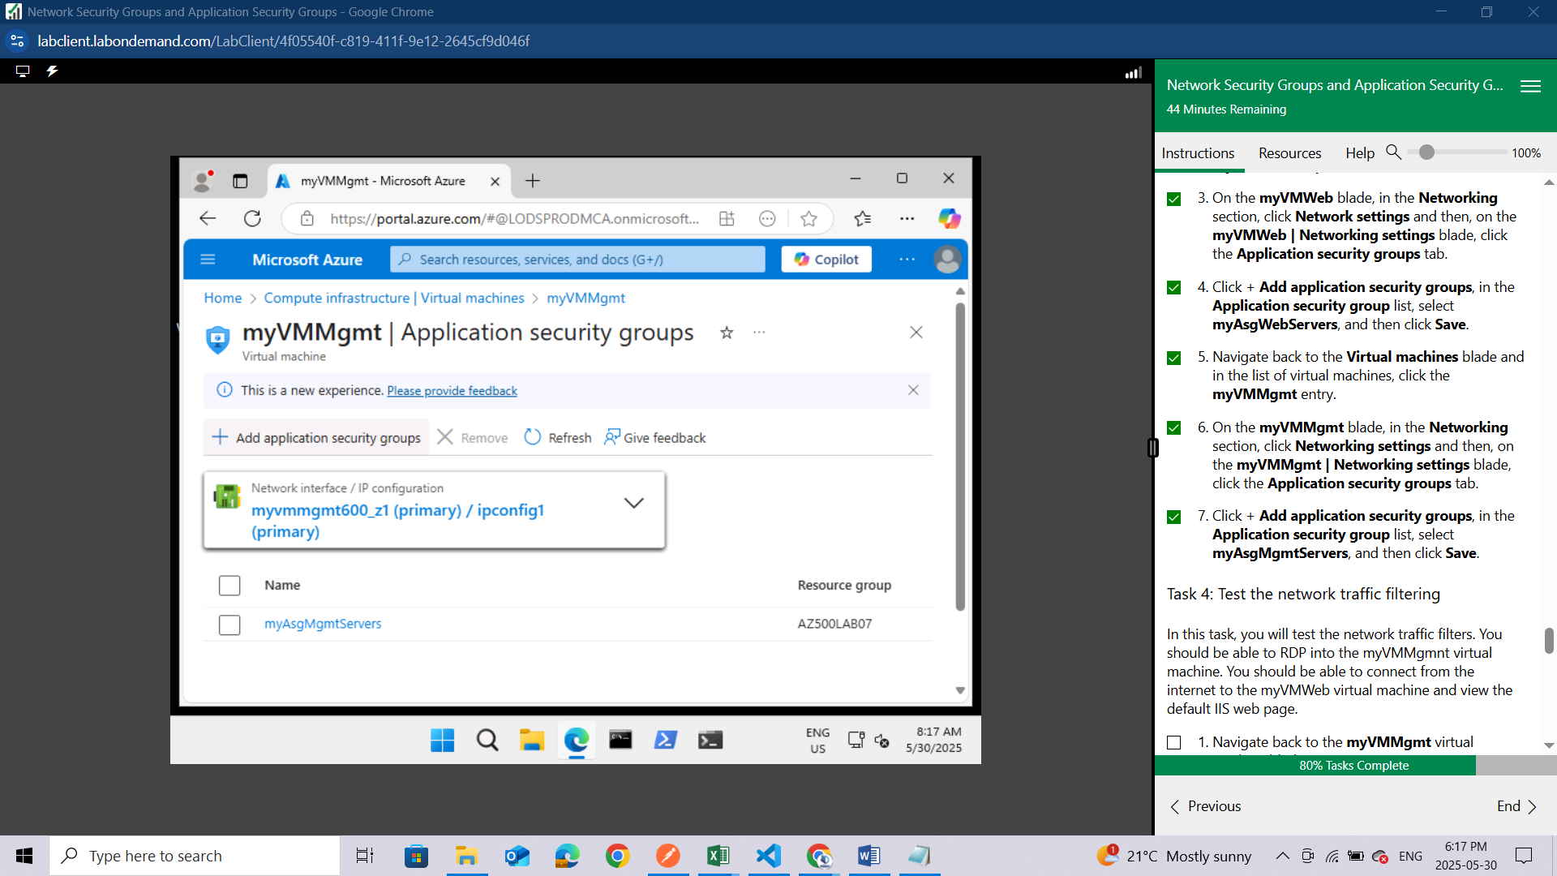

#### **Task 4: Test the network traffic filtering**

In this task, you will test the network traffic filters. You should be able to RDP into the myVMMgmnt virtual machine. You should be able to connect from the internet to the myVMWeb virtual machine and view the default IIS web page.

Navigate back to the **myVMMgmt** virtual machine blade.

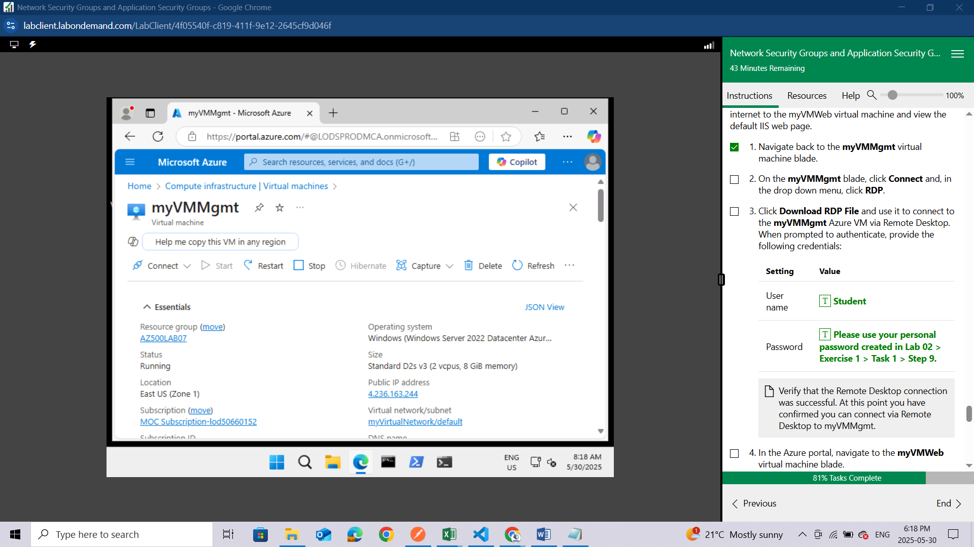

On the **myVMMgmt** blade, click **Connect** and, in the drop down menu, click **RDP**.

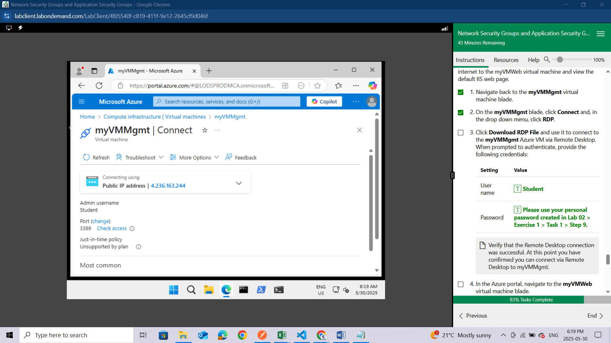Click **Download RDP File** and use it to connect to the **myVMMgmt** Azure VM via Remote Desktop.

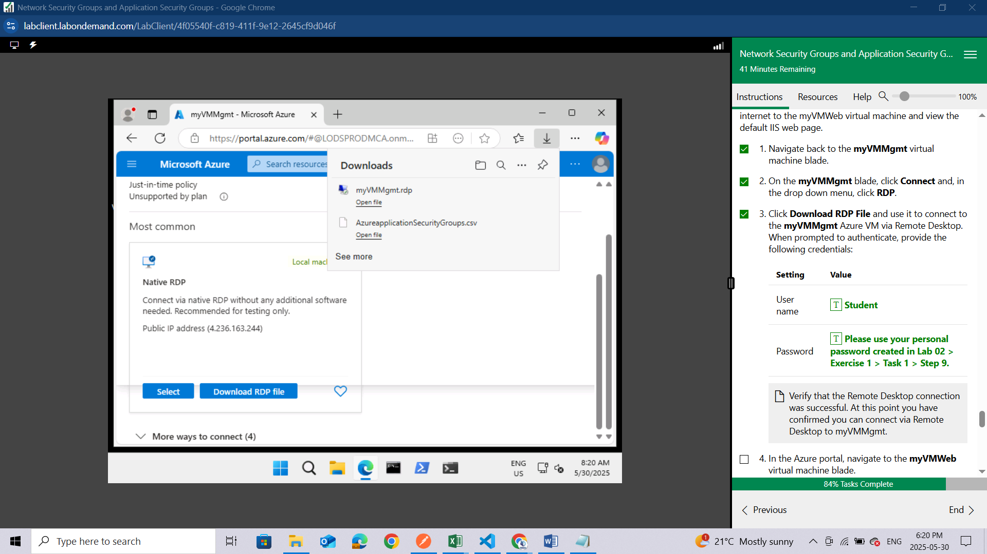

When prompted to authenticate, provide the following credentials:

| **Setting** | **Value** |
| --- | --- |
| User name | **Student** |
| Password | **Please use your personal password created in Lab 02 > Exercise 1 > Task 1 > Step 9.** |

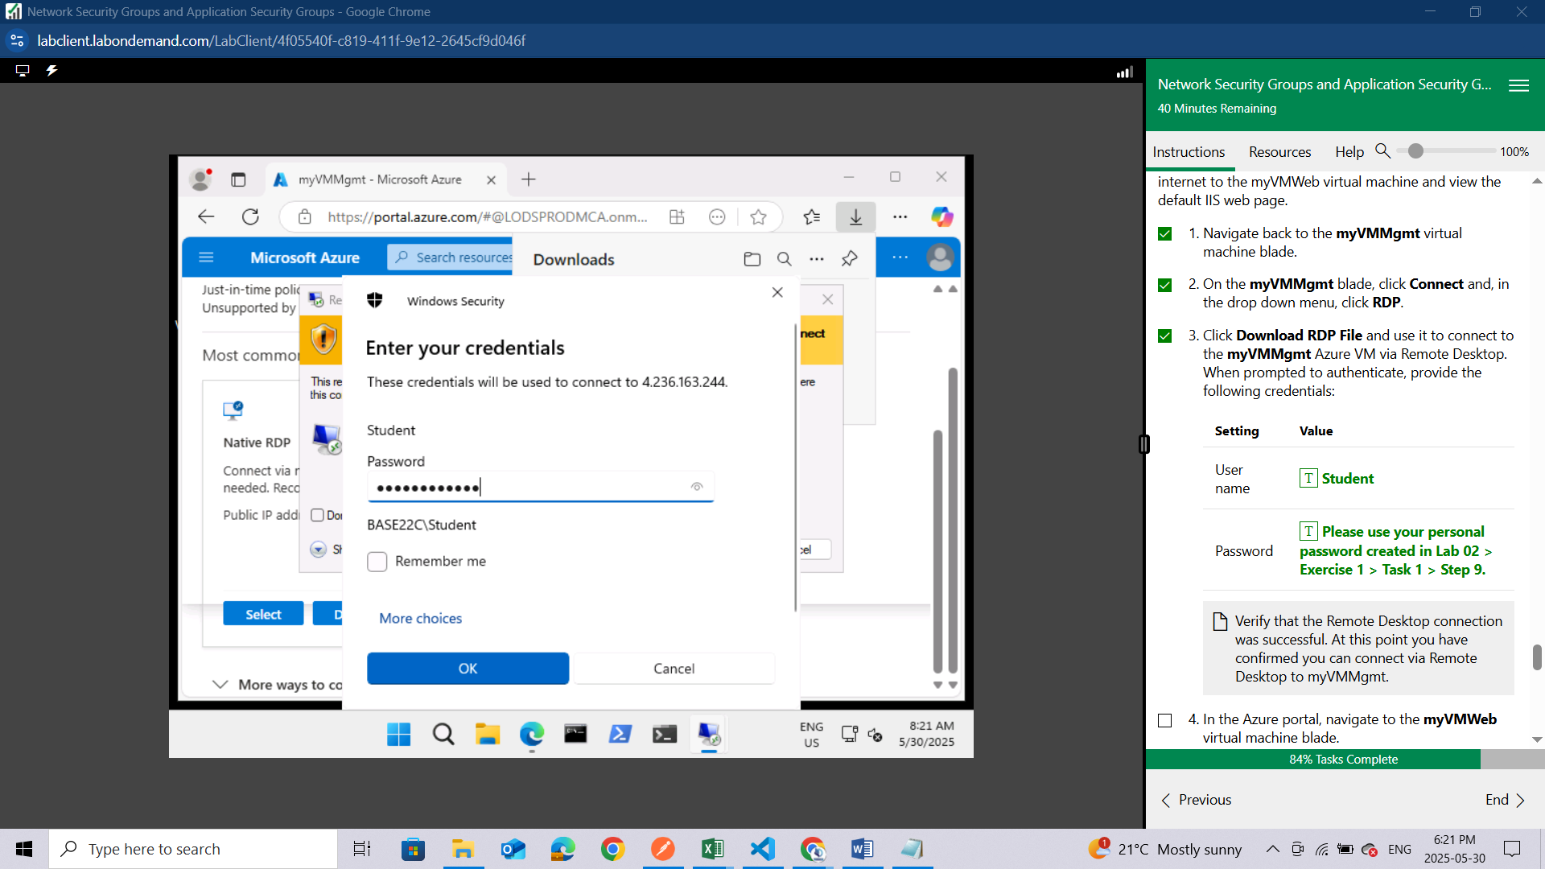

When prompted to accept certificate with the errors click **YES,** after this you should be able to be in your RDP

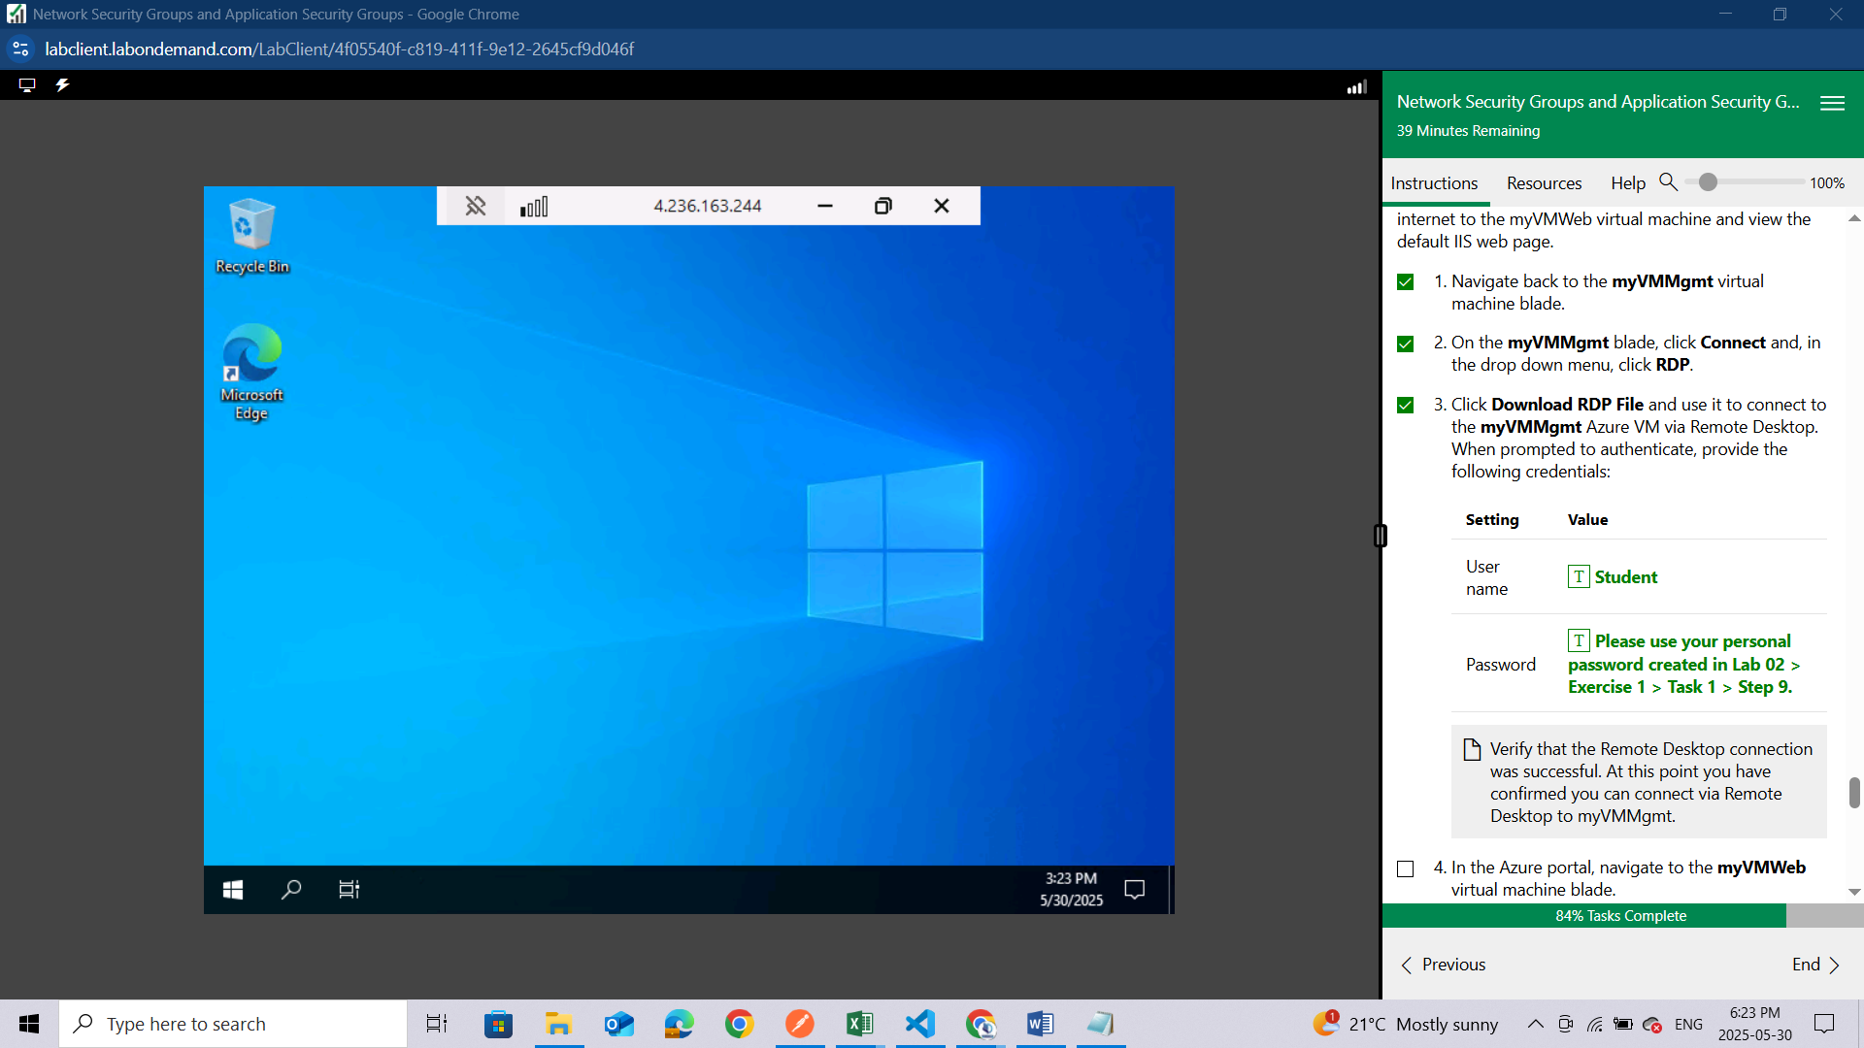

Verify that the Remote Desktop connection was successful. At this point you have confirmed you can connect via Remote Desktop to myVMMgmt.

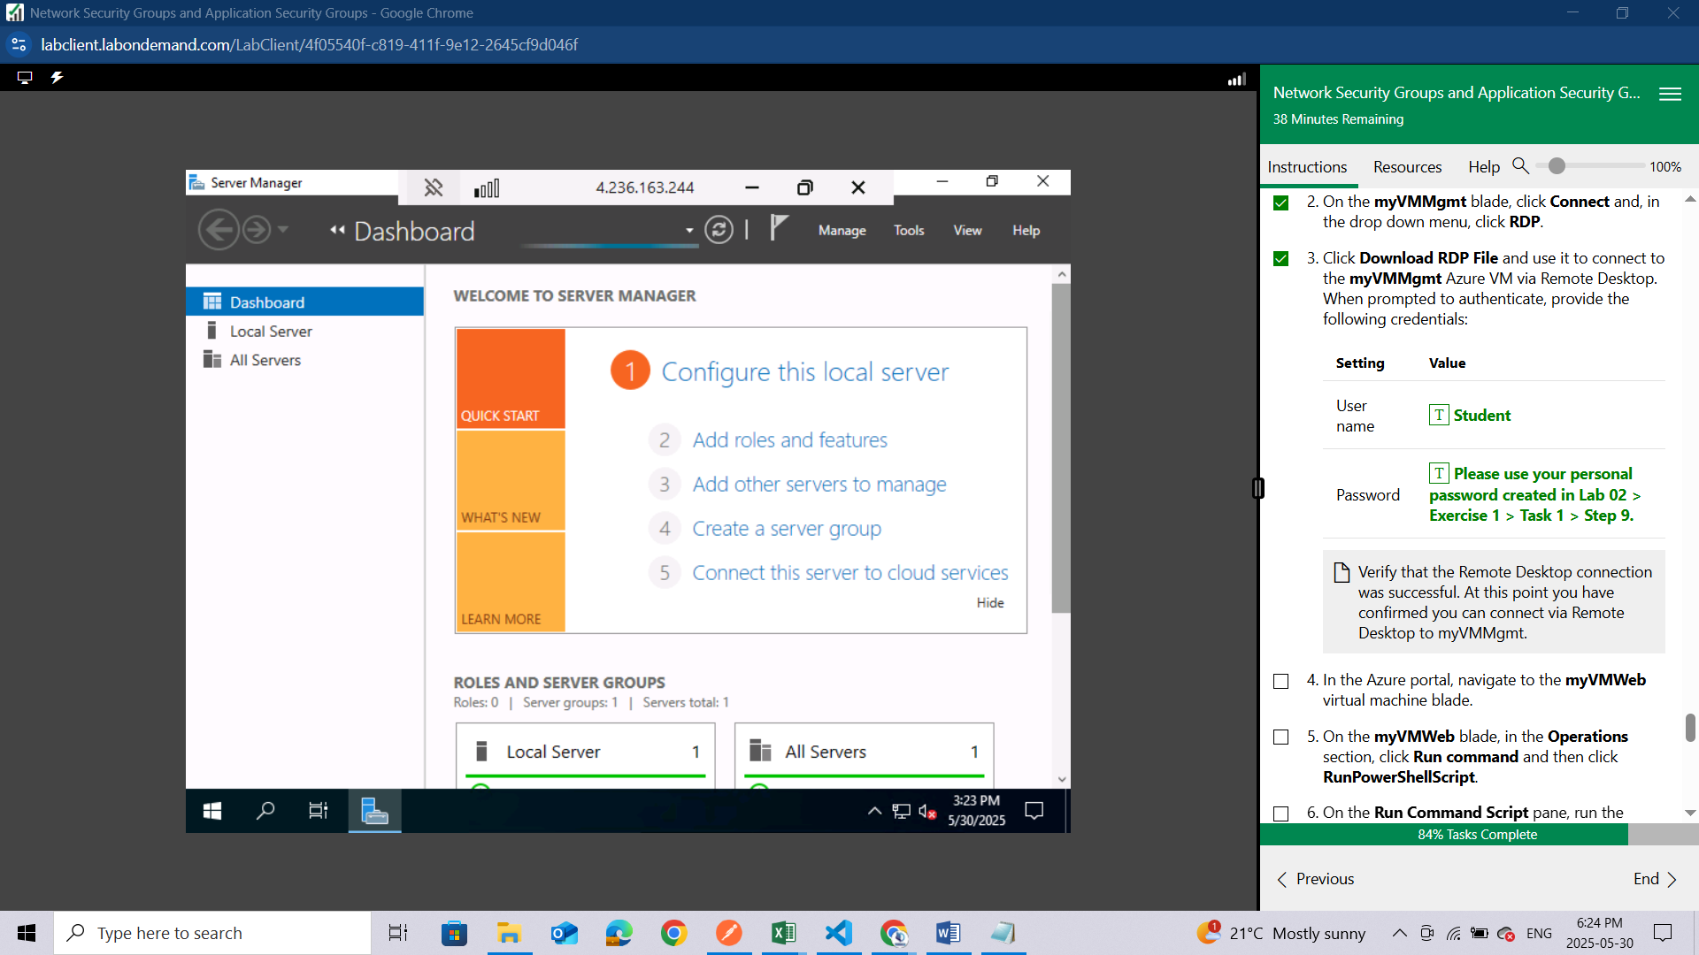

In the Azure portal, navigate to the **myVMWeb** virtual machine blade.

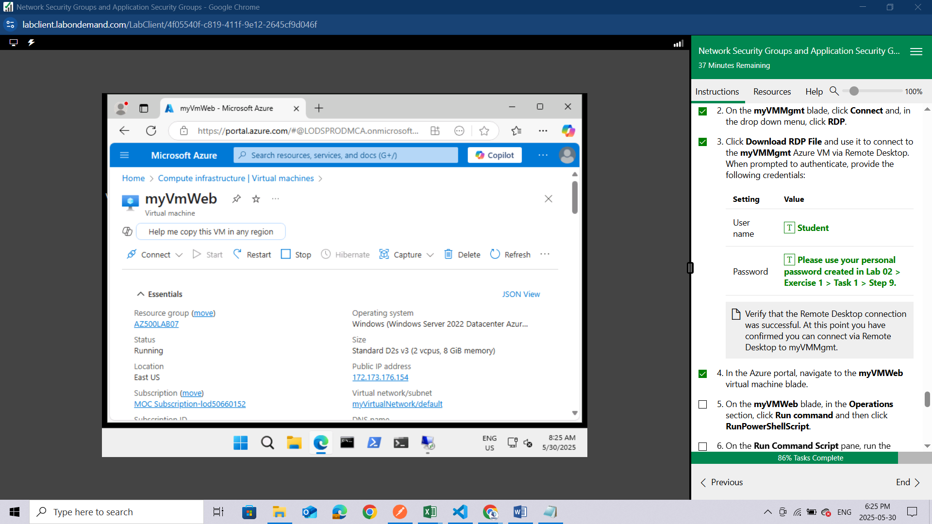

On the **myVMWeb** blade, in the **Operations** section, click **Run command**

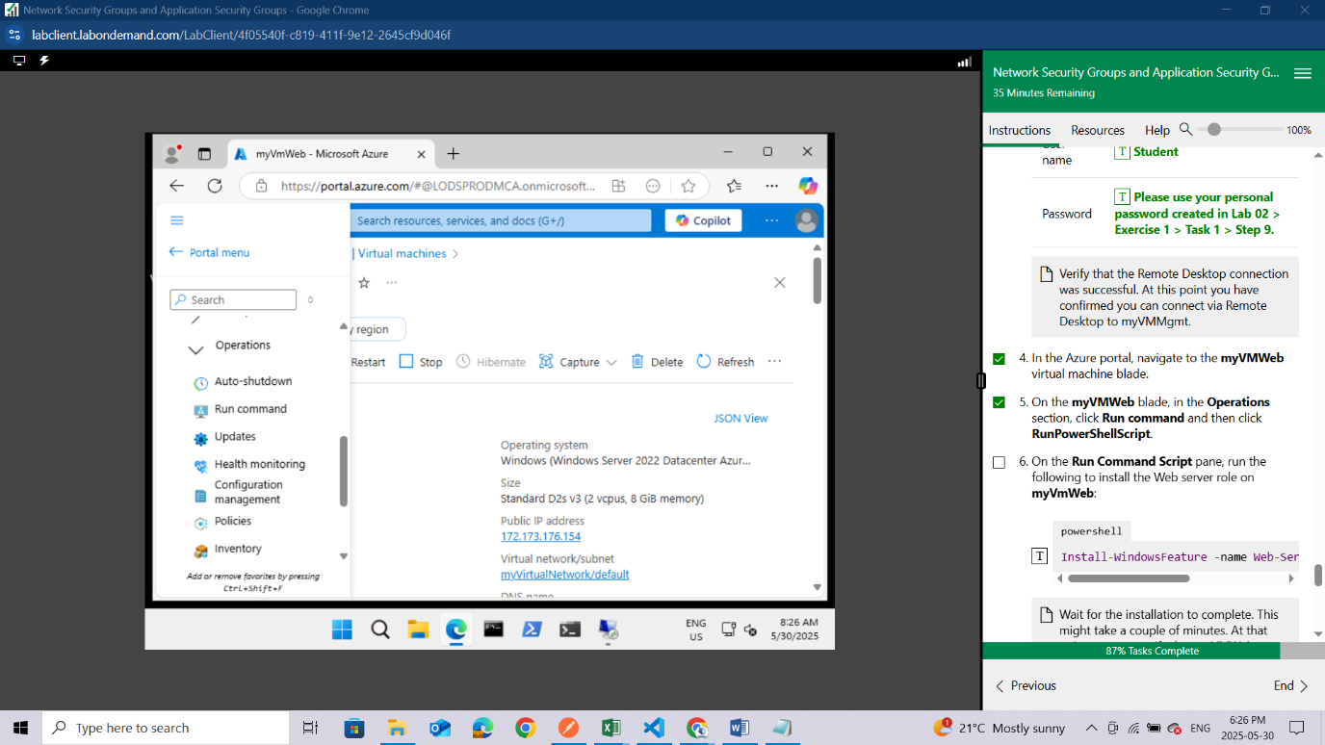

and then click **RunPowerShellScript**.

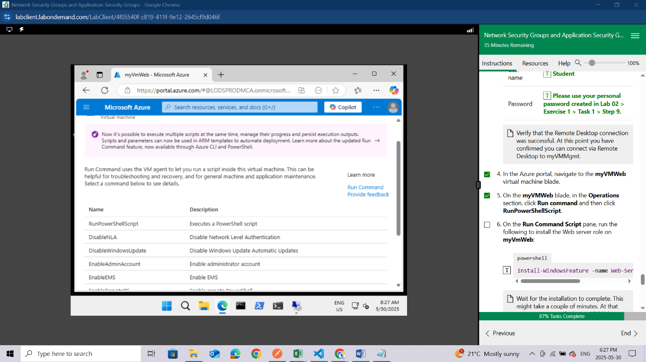

On the **Run Command Script** pane, run the following to install the Web server role on **myVmWeb**:

After typing click **RUN** tab to run the script.

powershell

Install-WindowsFeature -name Web-Server –IncludeManagementTools

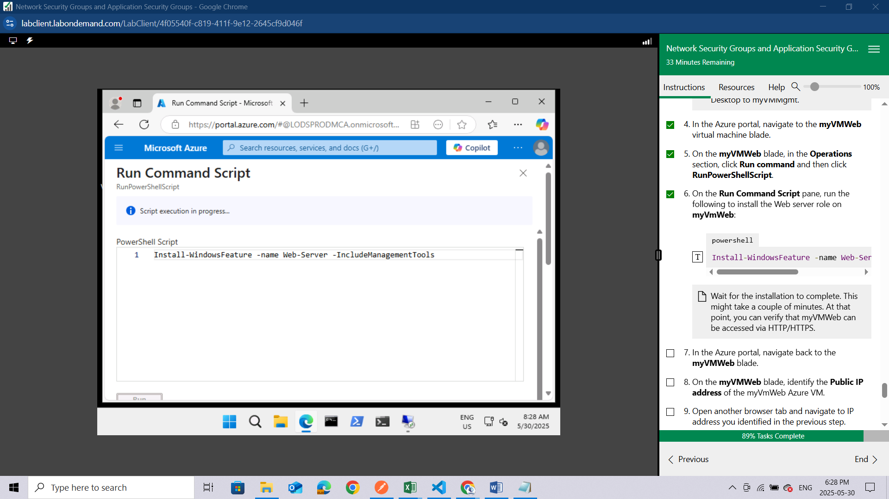

Wait for the installation to complete. This might take a couple of minutes. At that point, you can verify that myVMWeb can be accessed via HTTP/HTTPS.

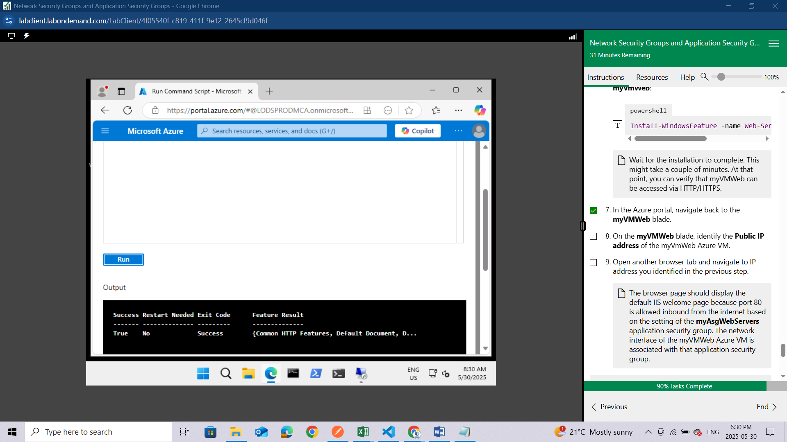

In the Azure portal, navigate back to the **myVMWeb** blade.

On the **myVMWeb** blade, identify the **Public IP address** of the myVmWeb Azure VM.

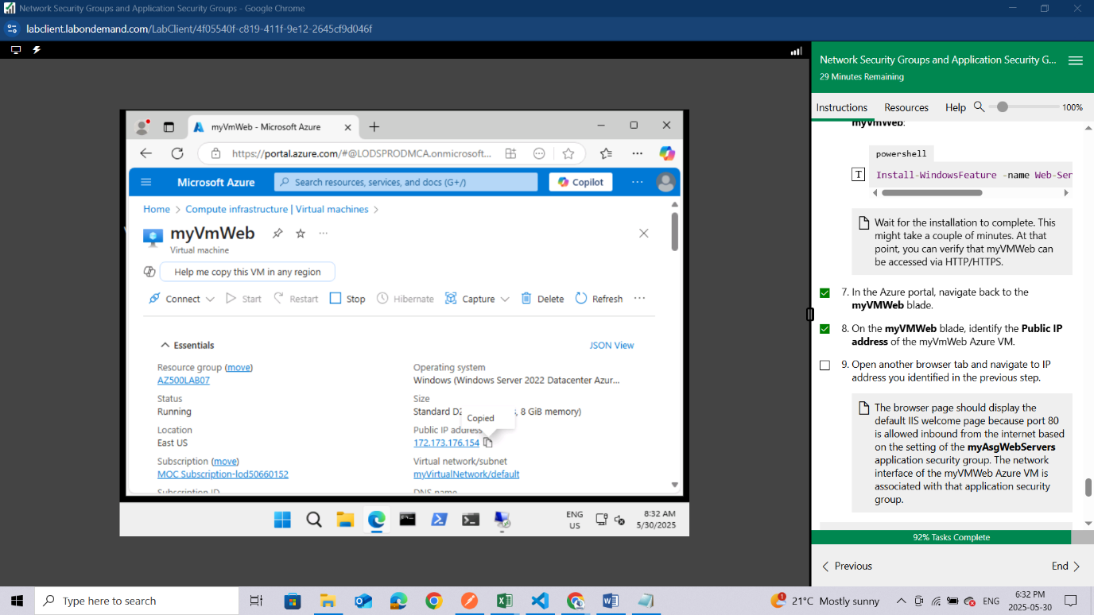

Open another browser tab and navigate to IP address you identified in the previous step.

The browser page should display the default IIS welcome page because port 80 is allowed inbound from the internet based on the setting of the **myAsgWebServers** application security group. The network interface of the myVMWeb Azure VM is associated with that application security group.

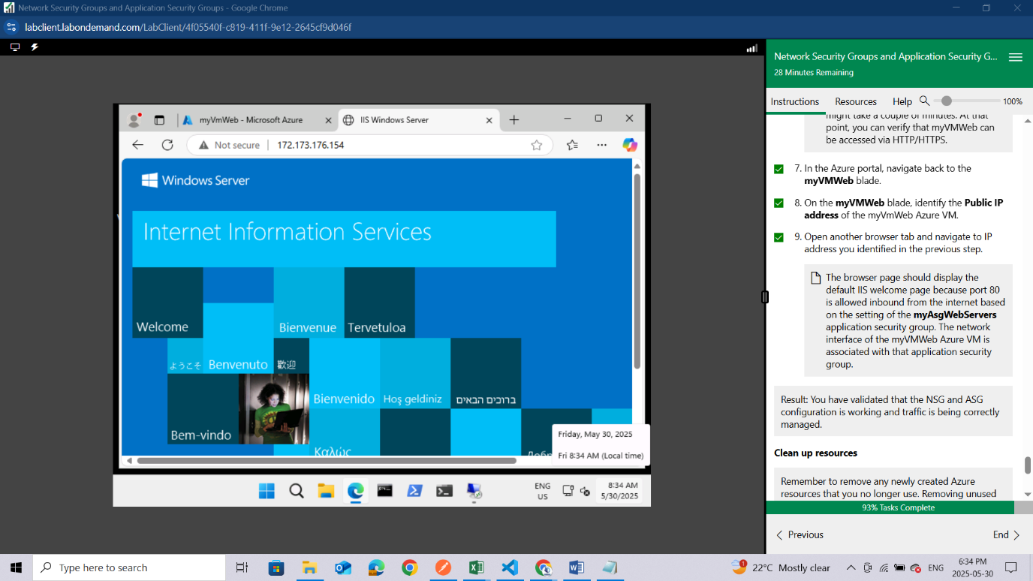

Result: You have validated that the NSG and ASG configuration is working and traffic is being correctly managed.

### **Clean up resources**

Remember to remove any newly created Azure resources that you no longer use. Removing unused resources ensures you will not incur unexpected costs.

Open the Cloud Shell by clicking the first icon in the top right of the Azure Portal. If prompted, select **PowerShell**

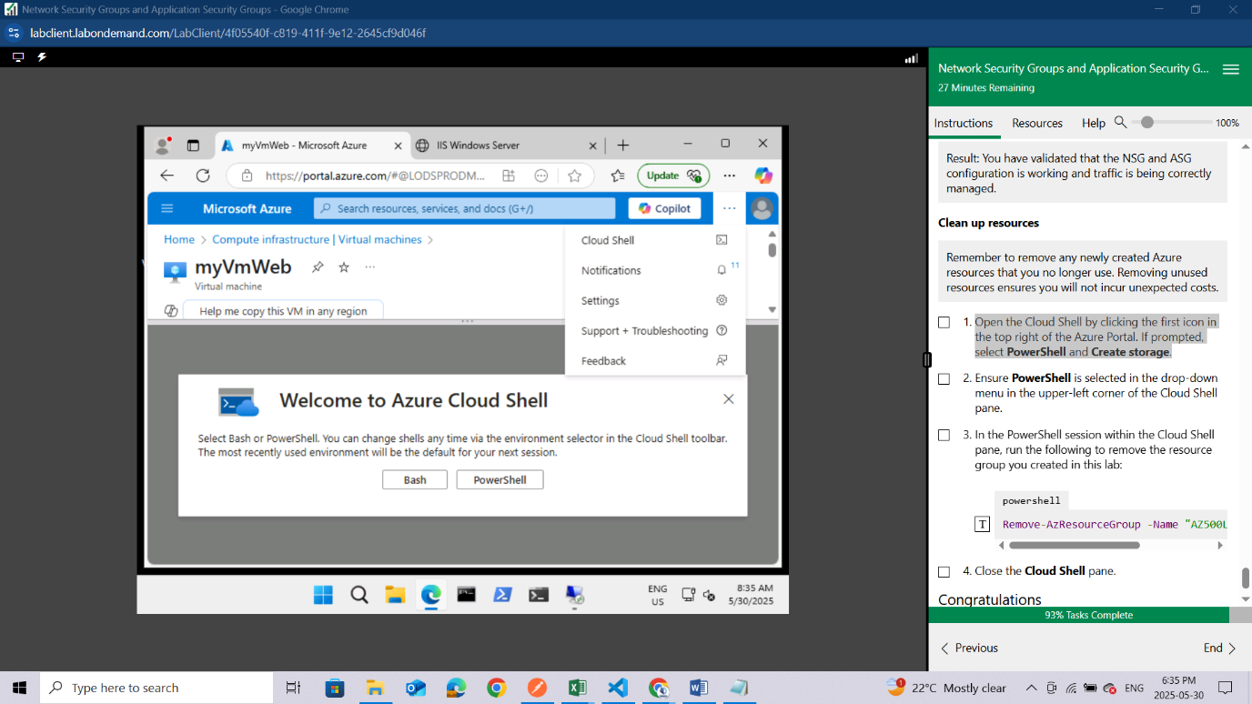

and **Create storage**.

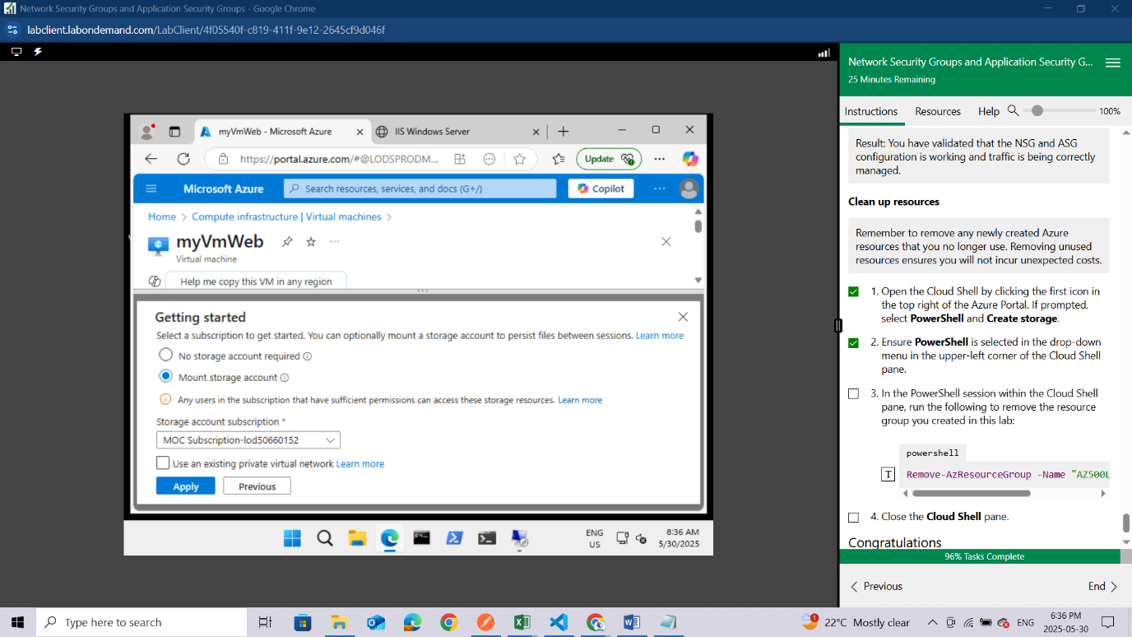

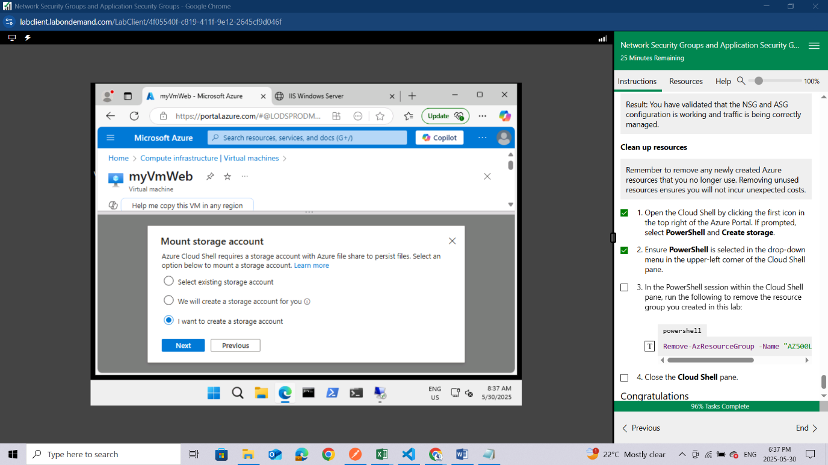

For storage account name and file share give them a name of your choice

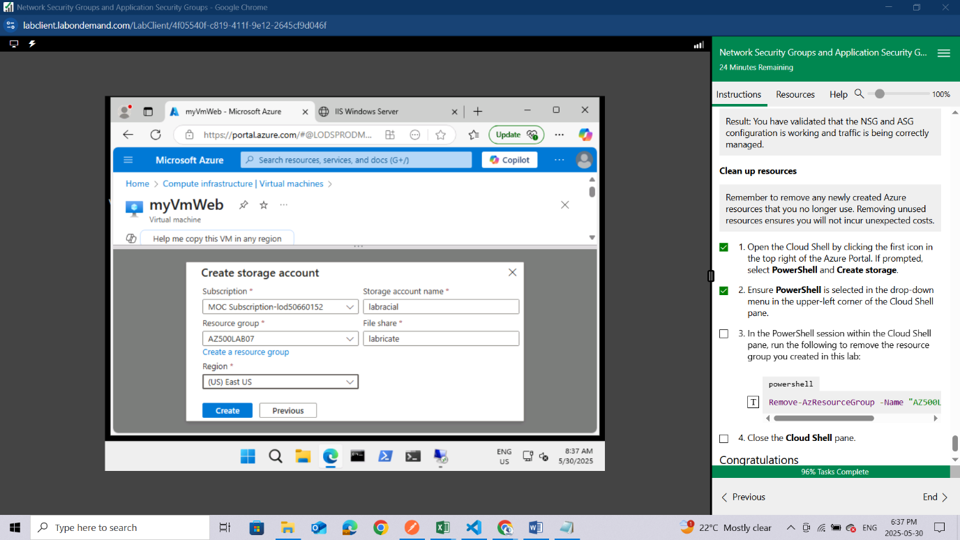

Ensure **PowerShell** is selected in the drop-down menu in the upper-left corner of the Cloud Shell pane.

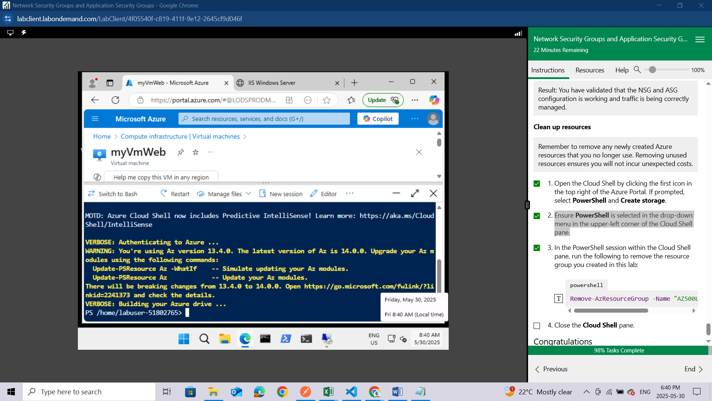

In the PowerShell session within the Cloud Shell pane, run the following to remove the resource group you created in this lab:

powershell

Remove-AzResourceGroup -Name "AZ500LAB07" -Force –AsJob

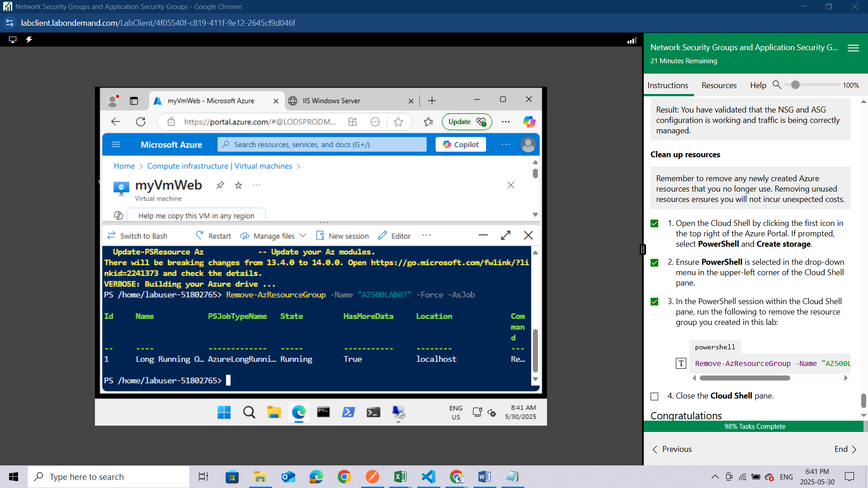

Close the **Cloud Shell** pane.

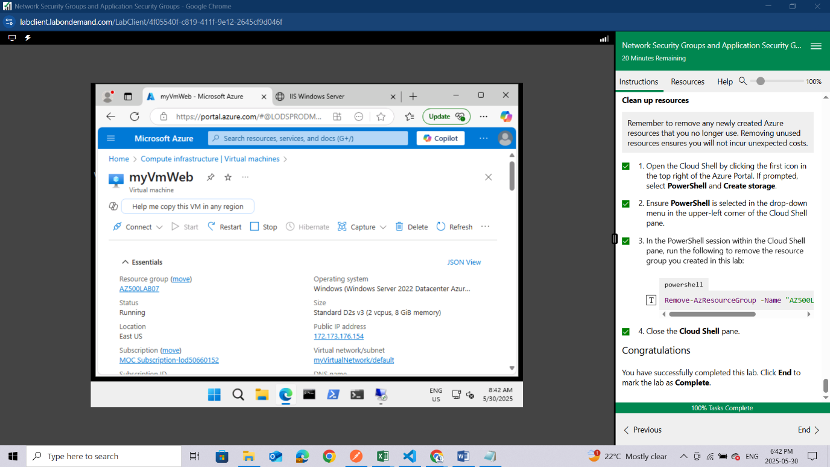

### **Congratulations**

You have successfully completed this lab. Click **End** to mark the lab as **Complete**.

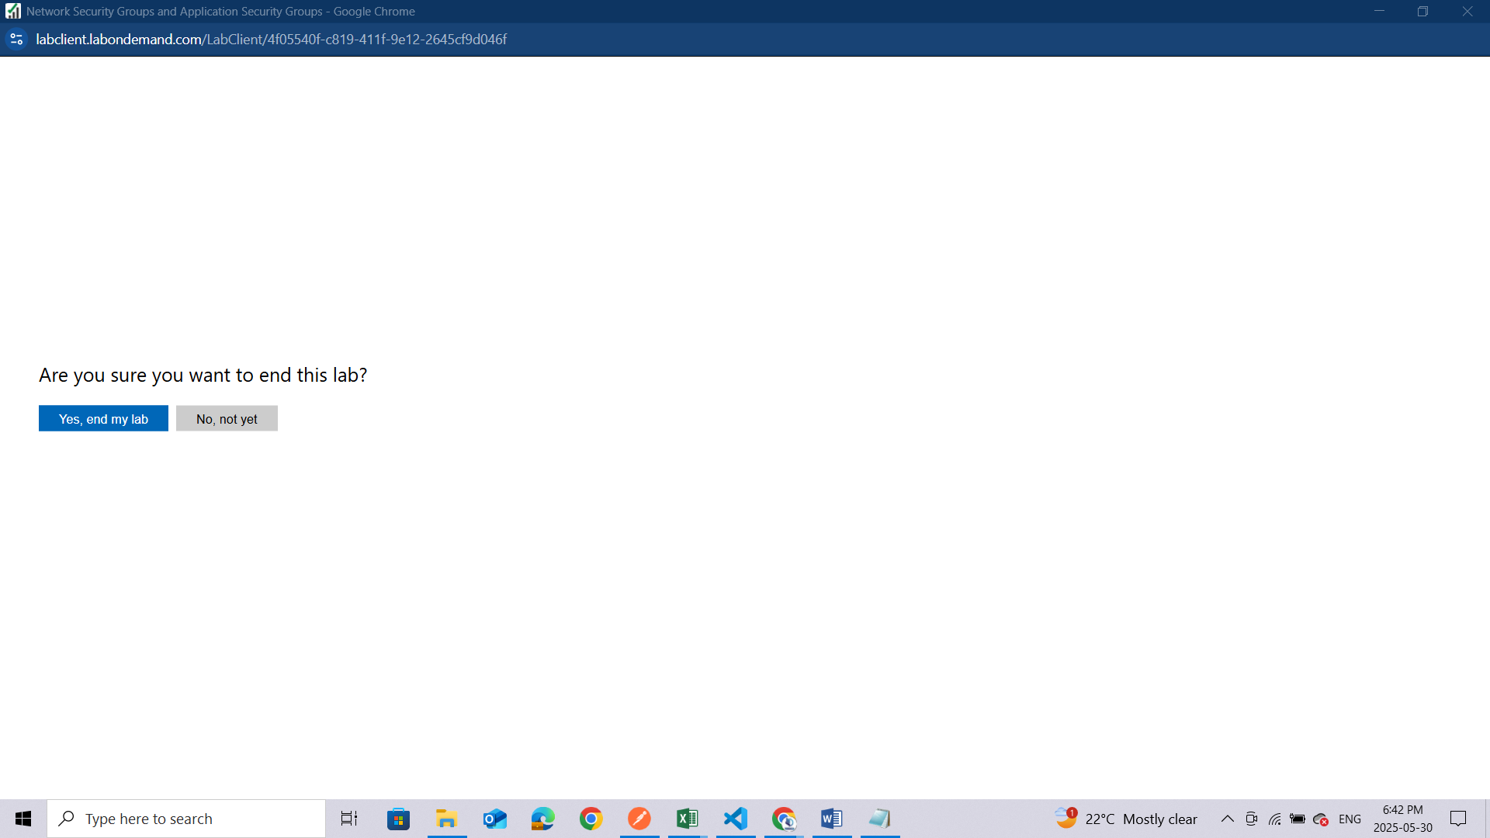

## Conclusion

Completing this lab deepened my understanding of how **Application Security Groups (ASGs)** and **Network Security Groups (NSGs)** work together to secure resources in Azure. By assigning the Web Servers and Management Servers to separate ASGs, I was able to simplify the process of applying targeted security rules. Using NSGs, I configured inbound and outbound rules to allow RDP access only to the Management Servers and ensure the Web Servers could serve web traffic over the internet. This hands-on experience helped me see the value of grouping resources logically and controlling access at a granular level. It was a great opportunity to apply security best practices in a cloud environment, and I'm eager to keep learning and building on these skills.